**Workshop: Project Fundamentals**

Workshop for the ["ASP.NET Advanced" course @ SoftUni](https://softuni.bg/trainings/4107/asp-net-advanced-june-2023)

The "**House** **Renting** **System**" **ASP.NET Core MVC App** is a Web application for **house renting**. **Users** can look at **all** **houses** with their **details**, **rent a house** and look at **their rented houses**. They can also **become** **Agents**. **Agents** can **add houses**, see their **details** and **edit** and **delete** only **houses they added**. The **Admin** has **all privileges** of **Users** and **Agents** and can see **all registrations** in the app and **all made rents**.

We will implement the app during the workshops in the course.

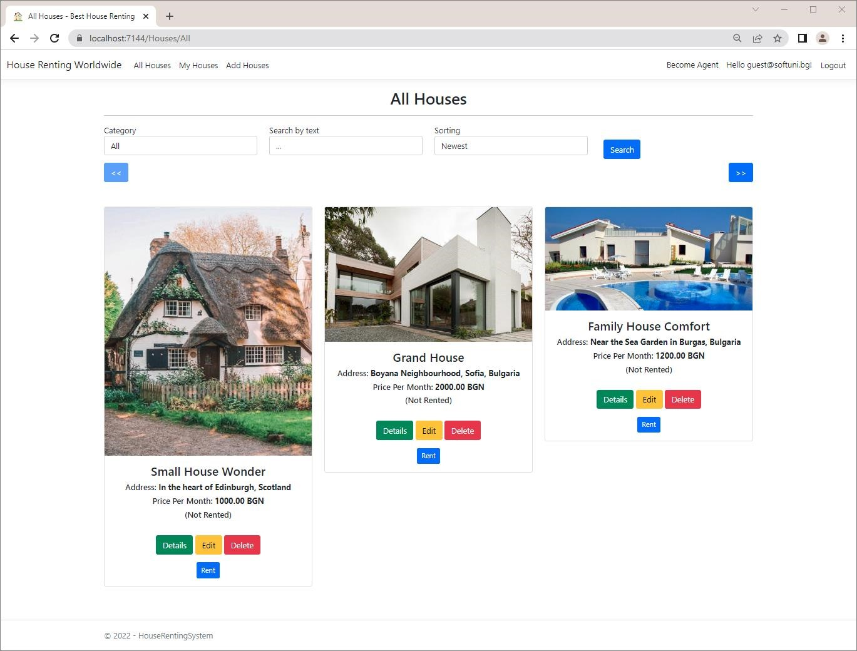

# Create the Project

Our first task is to create an **ASP.NET Core MVC application** in **Visual** **Studio**. Open Visual Studio and create a new **ASP.NET Core Web App (Model-View-Controller)** with and **Individual Accounts** **Authentication** **type**, as we want to have "**Register**" and "**Login**" functionalities. The app name should be "**HouseRentingSystem**".

# Examine the App in the Browser

**Run** the created app in the **browser**. It should have **four pages** for now – "**Home**", "**Privacy**", "**Register**" and "**Login**" **pages**. The "**Home**" **page** looks like this:

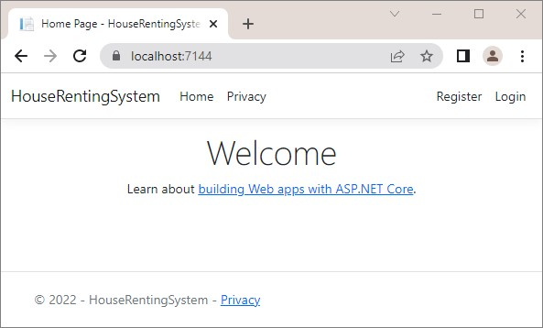

# Clean Project

As you know, **ASP.NET Core** gives us a pretty good **MVC template** to work on. However, we should now define our **own style of writing** **and** **formatting code**, which will be used for the **whole app**. We will do this as it is important for our code to **look good** and be **cleaner** and **more readable**. In addition, in this way we will also **examine the** **project files and classes** better.

## Step 1: Modify the Program class

First, go to **Program.cs** and look at how it is written. We should remove code comments. Now improve the configuration of the services. It is good for all commands to have an empty line between them. It should look like this:

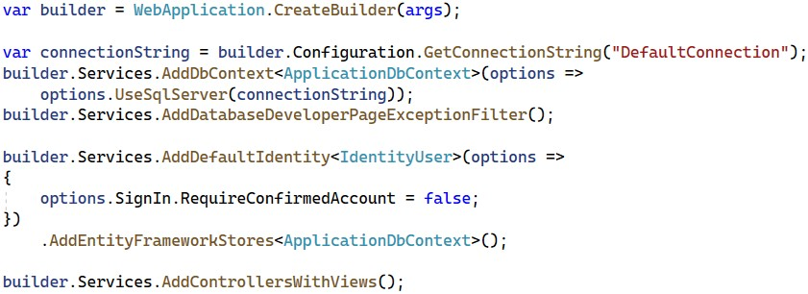

You can see that the **controller route mapping** is the **default** one.

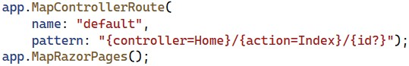

For this reason, you can replace the **MapControllerRoute(…)** method with the **MapDefaultControllerRoute()** one:



## Step 2: Modify the HomeController Class

Now let's clean the **HomeController** **class**. To start with, we won't need a **logging functionality** in our app, so remove the **logger** **property** and the **whole class constructor**, which initializes it. We can also make the **actions** with **arrow functions** and remove the "**Privacy**" page from our app, as we won't be needing it.

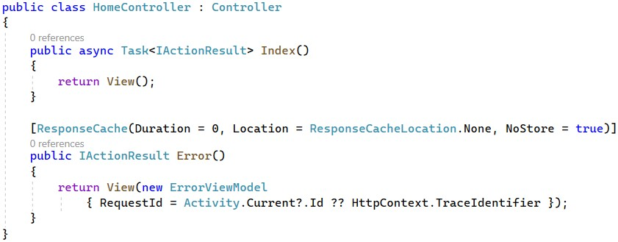

We should **remove** the "**Privacy.cshtml"** **view** from our project. Find it in the "**/Views/Home**" **folder** and **delete it**:

## Step 3: Modify the _Layout.cshtml File

The "**_Layout.cshtml**" **view** in our app defines how our **header** and **footer look**.

Go to the **view file** in the "**/Views/Shared**" **folder** and let's make some changes. Start by **removing** the "**Privacy**" **page links** from the **header** and the **footer**, as we deleted the page. Remove the following lines from the **header**:

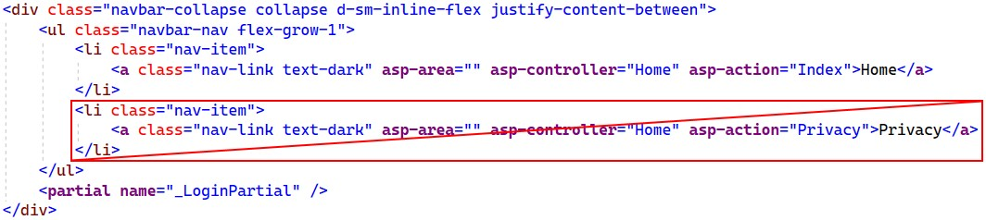

Then, **remove** the **<a>** **tag** with the link from the **footer**:

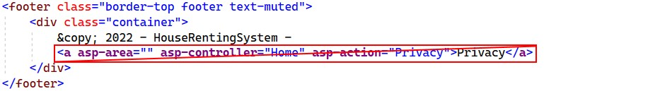

You can also replace the year with **@DateTime.Now.Year**:



Modify the **title** of the app in the **<head>** **tag** and **write a meaningful one**:

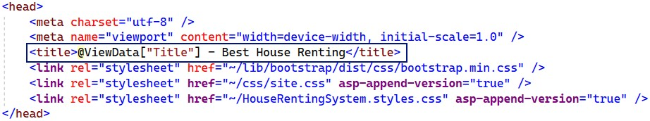

Then, **change the name** of the app in the **header**, as well:



This **name** is in an **<a>** **tag**, as it is a **hyperlink** to the **main page** of the app.

Now the **result** in the **browser** is the following:

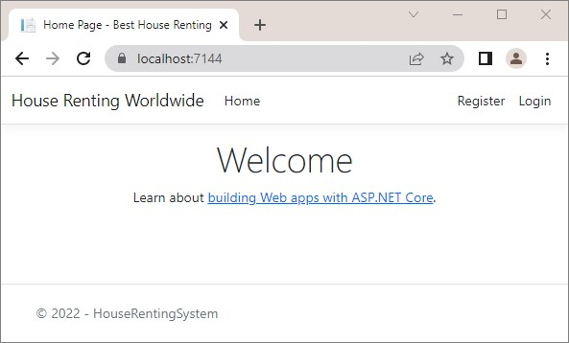

# Add Favicon

In this task, we will see how to **add a favicon** in our **site's tab** in the **browser**. To do this, we will first go to <https://favicon.io/>and **generate a favicon**. **Create** one by yourself and **download** it like this:

→

→

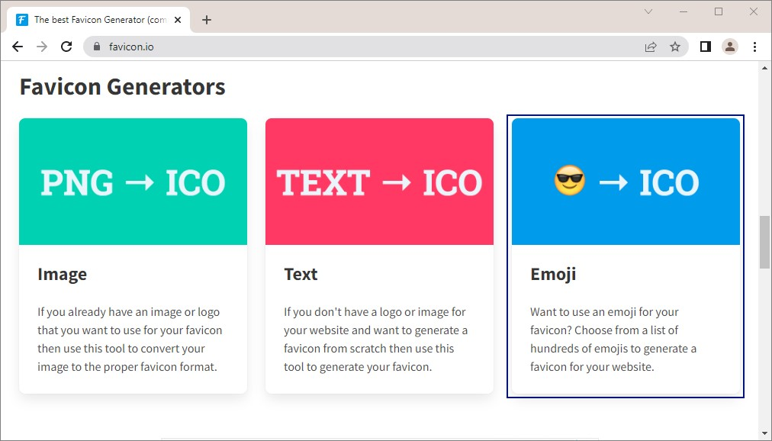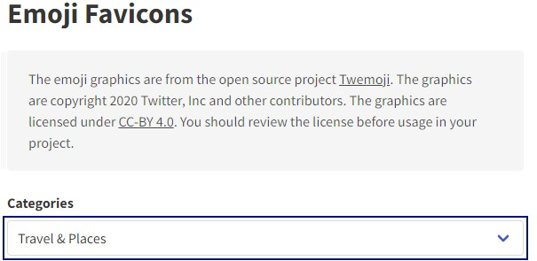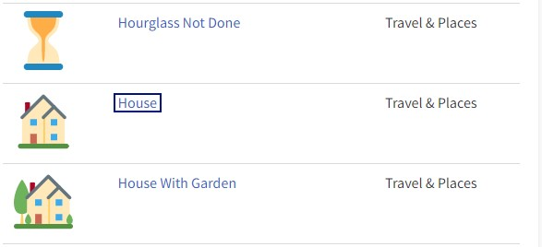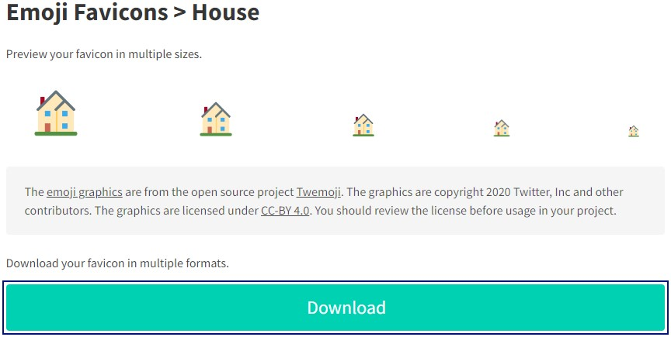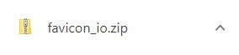

**Open** the **.zip** **file** and **search for** the **favicon.ico** **file**:

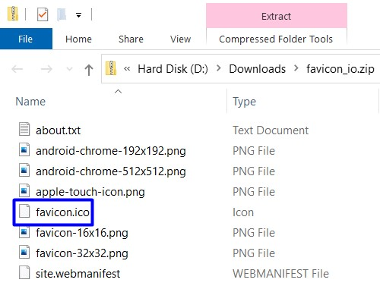

You should now **copy** and **paste this file** in the **project**. **Open the project** in **File** **Explorer** and look for the **favicon.ico** **file** in the "**wwwroot**" **directory**. **Replace the old favicon** with the **new** one:

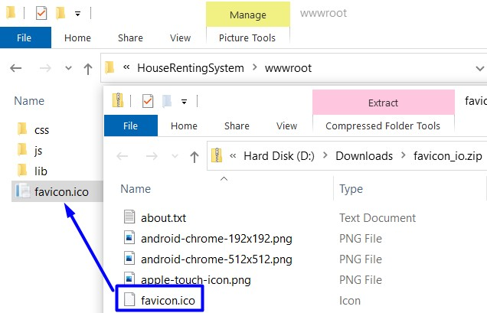

When you are ready, **reload the project** in **VS** and **run it in the browser**. The **new favicon** should be visible in the **browser tab**:

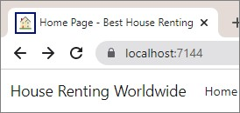

# Create Entity Model Classes

Now, we will create the **data models**, which we will need for our **database**. We will have **three data model** **classes** – **House**, **Category** and **Agent**.

Create the above classes in the "**Data**" **folder** of the project. They should be in a **separate folder** from the **ApplicationDbContext** class – the "**Models**" **folder**.

First, let's create a separate class with constants for the max and min length values. In the "**Data**" folder, create the **DataConstants** class.

## Step 1: Add Category Entity Class

The **Category** **class** should have the following **properties**:

* **Id** – a unique **integer**, Primary Key
* **Name** – a **string** with max length **50** (**required**)
* **Houses** – a **collection** of **House**

Our first **entity** **class** should look like this:

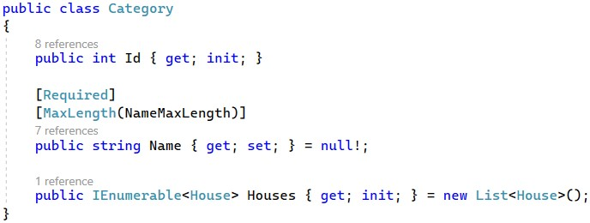

## Step 2: Add House Entity Class

The **House** class should have the following **properties**:

* **Id** – a unique **integer**, Primary Key
* **Title** – a **string** with min length **10** and max length **50** (**required**)
* **Address** – a **string** with min length **30** and max length **150** (**required**)
* **Description** – a **string** with min length **50** and max length **500** (**required**)
* **ImageUrl** – a **string** (**required**)
* **PricePerMonth** – a **decimal** with min value **0** and max value **2000** (**required**)
* **CategoryId** – an **integer** (**required**)
* **Category** – a **Category** object
* **AgentId** – an **integer** (**required**)
* **Agent** – an **Agent** object
* **RenterId** – a **string**

## Step 3: Add Agent Entity Class

The **Agent** **class** should have the following **properties**:

* **Id** – a unique **integer**, Primary Key
* **PhoneNumber** – a **string** with min length **7** and max length **15** (**required**)
* **UserId** – a **string** (**required**)
* **User** – an **IdentityUser** object

# Modify DbContext Class

As we now have **all entity classes** your app needs, use them for the database. To start with, it is a good idea to **rename** the **ApplicationDbContext** **class** to "**HouseRentingDbContext**", so that it is connected to the idea of our application.

Create **DbSet** **properties** for **all tables** in the **database**:

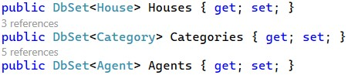

Next, we should **override** the **OnModelCreating(ModelBuilder** **builder)** **method** in the **HouseRentingDbContext** **class**:

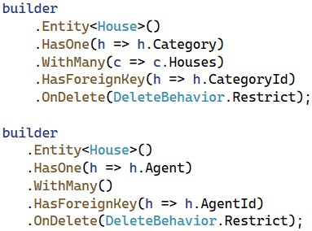

Don't forget to invoke the base **OnModelCreating()** method at the end.

Now our **database structure** is ready. If you migrate it now, however, it will be **created with empty tables**. For this reason, let's **seed some data** **to fill in the database tables**.

# Seed Database

Now we need to **populate the database** with an **initial set of data**. This will include **two users**, an **agent**, **three** **categories** and **three houses**.

First, **create properties** for the above **objects** in the **HouseRentingDbContext** **class**:

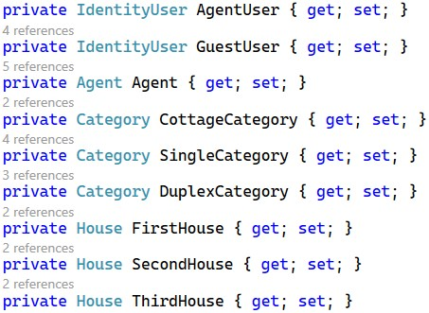

Then, we will use **separate methods** to **add data to these objects**, which will be **added to the corresponding database** **tables** in the **OnModelCreating(…)** **method**. Add the following lines to the method, before invoking the base one:

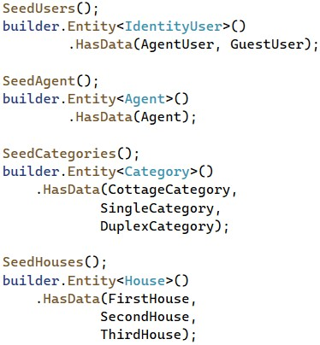

As you remember from the previous workshops, it is important that the above **seeding methods are invoked in the correct order**, as they **depend** on each other.

As the methods have a lot of data, you can copy the code from here:

|  |
| --- |
| private void SeedUsers()  {  var hasher = new PasswordHasher<IdentityUser>();    AgentUser = new IdentityUser()  {  Id = "dea12856-c198-4129-b3f3-b893d8395082",  UserName = "agent@mail.com",  NormalizedUserName = "agent@mail.com",  Email = "agent@mail.com",  NormalizedEmail = "agent@mail.com" };    AgentUser.PasswordHash =  hasher.HashPassword(AgentUser, "agent123");    GuestUser = new IdentityUser()  {  Id = "6d5800ce-d726-4fc8-83d9-d6b3ac1f591e",  UserName = "guest@mail.com",  NormalizedUserName = "guest@mail.com",  Email = "guest@mail.com",  NormalizedEmail = "guest@mail.com"  };    GuestUser.PasswordHash =  hasher.HashPassword(AgentUser, "guest123");  }  private void SeedAgent()  {  Agent = new Agent()  { |

|  |
| --- |
| Id = 1,  PhoneNumber = "+359888888888",  UserId = AgentUser.Id  };  }  private void SeedCategories()  {  CottageCategory = new Category()  {  Id = 1,  Name = "Cottage"  };    SingleCategory = new Category()  {  Id = 2,  Name = "Single-Family"  };    DuplexCategory = new Category()  {  Id = 3,  Name = "Duplex"  };  }  private void SeedHouses()  {  FirstHouse = new House()  {  Id = 1,  Title = "Big House Marina",  Address = "North London, UK (near the border)",  Description = "A big house for your whole family. Don't miss to buy a house with three bedrooms.",  ImageUrl = "https://www.luxury-architecture.net/wpcontent/uploads/2017/12/1513217889-7597-FAIRWAYS-010.jpg",  PricePerMonth = 2100.00M,  CategoryId = DuplexCategory.Id,  AgentId = Agent.Id,  RenterId = GuestUser.Id  };    SecondHouse = new House()  {  Id = 2,  Title = "Family House Comfort",  Address = "Near the Sea Garden in Burgas, Bulgaria",  Description = "It has the best comfort you will ever ask for. With two bedrooms, it is great for your family.",  ImageUrl =  "https://cf.bstatic.com/xdata/images/hotel/max1024x768/179489660.jpg?k=2029f6d9589b4  9c95dcc9503a265e292c2cdfcb5277487a0050397c3f8dd545a&o=&hp=1",  PricePerMonth = 1200.00M,  CategoryId = SingleCategory.Id,  AgentId = Agent.Id |

};

ThirdHouse = new House()

{

Id = 3,

Title = "Grand House",

Address = "Boyana Neighbourhood, Sofia, Bulgaria",

Description = "This luxurious house is everything you will need. It is just excellent.", ImageUrl =

"https://i.pinimg.com/originals/a6/f5/85/a6f5850a77633c56e4e4ac4f867e3c00.jpg",

PricePerMonth = 2000.00M,

CategoryId = SingleCategory.Id,

AgentId = Agent.Id

}; }

Note that only the **first house** has a **RenterId**, which means that it is **rented by the** **GuestUser**.

Now we have a **db** **context** with **seeded data** and our **database is ready to be migrated**.

# Create a Migration

We will now **create a migration** to the database. Before that, however, let's give the **database a good name**.

To do this, **edit the connection string** in the "**appsettings.json**" **file**. Set "**Database**" **name** to be "**HouseRentingSystem**":



Next, **open** the **Package** **Manager** **Console** to write **commands** for **managing migrations**. In the **console**, write a command for **adding a migration** to the "**Data/Migrations**" **folder** with a given **name** and **press** **[Enter]** to **execute it**. Now you should have a **new migration** in the "**Migrations**" **folder**.

**Examine the tables** and its **restrictions** in the **new migration** – if something is wrong, **delete the migration** with the "**Remove-Migration**" **command** or **delete the migration file**. Don't forget that you should also **delete the database** from SQL Server Management Studio, or errors will appear.

Now **run the app** in the browser – there should not be **any errors**. Then, look at the **newly-created database** in SQL Server Management Studio and **examine its tables** – all tables we created should be **present** and have the **right restrictions** and **relationships**.

Examine the **diagram of the database**, as well. It should look like this:

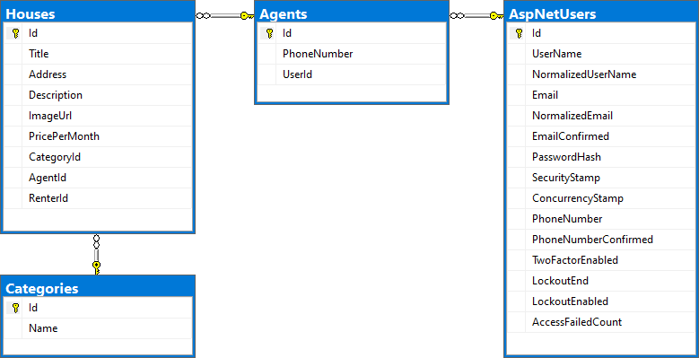

# Register and Log in the App

Go to the "**Register**" **page** in the "**HouseRentingSystem**" **app** and you should see the **registration form**:

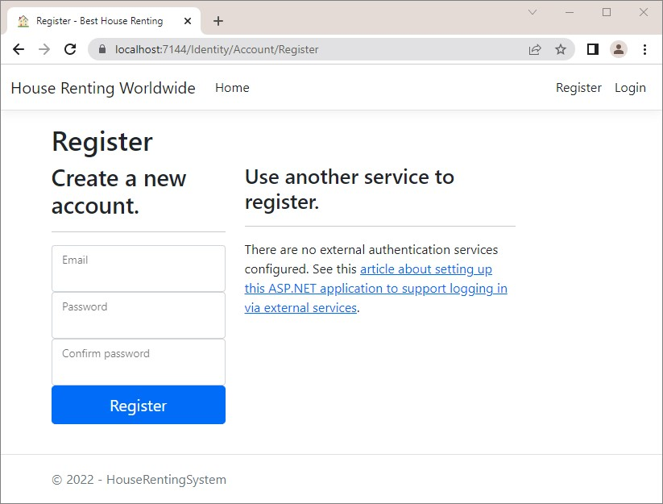

If you try to **fill in the form**, you will see that **password requirements are too strict** – change this by adding the following lines in **Program.cs**:

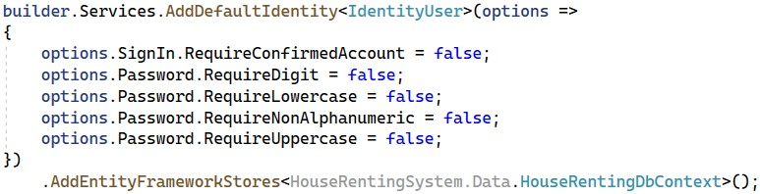

After this, **fill in** the "**Register**" **form** with **valid data** and you should be **logged**:

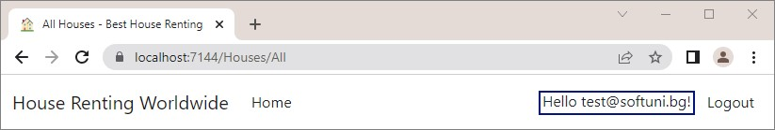

Also, the **new user** should be part of the **database** – check in the "**AspNetUsers**" **table**:

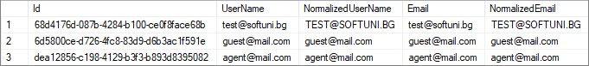

# Modify Navigation

Now, we should **change the navigation menu** to have **links** to the "**All** **Houses**", "**My** **Houses**", "**Add** **House**" and "**Become** **Agent**" **pages** when the **user is logged-in**.

When the **user is not logged-in**, the **navigation** should look like this:

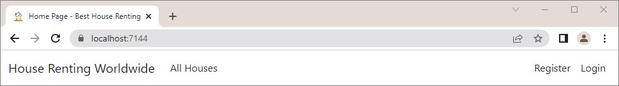

When the **user is logged-in**, it should be the following:

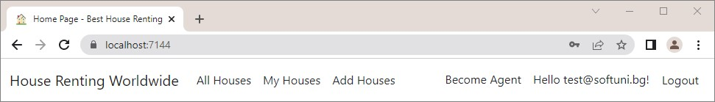

To do this, we need to **modify** the "**_Layout.cshtml"** and **"_LoginPartial.cshtml"** **views** in the "**/Views/Shared**" **folder**, as they are **responsible for the navigation menu**.

First, to **change links on the left side** of the page, go to the **"_Layout.cshtml"** file. In it, we want to **add links to the** **pages** depending on whether the **user is authenticated**. Use an **if** **statement** in the **Razor view** and the **Identity.IsAuthenticated** **property** to check whether the **current user is authenticated**:

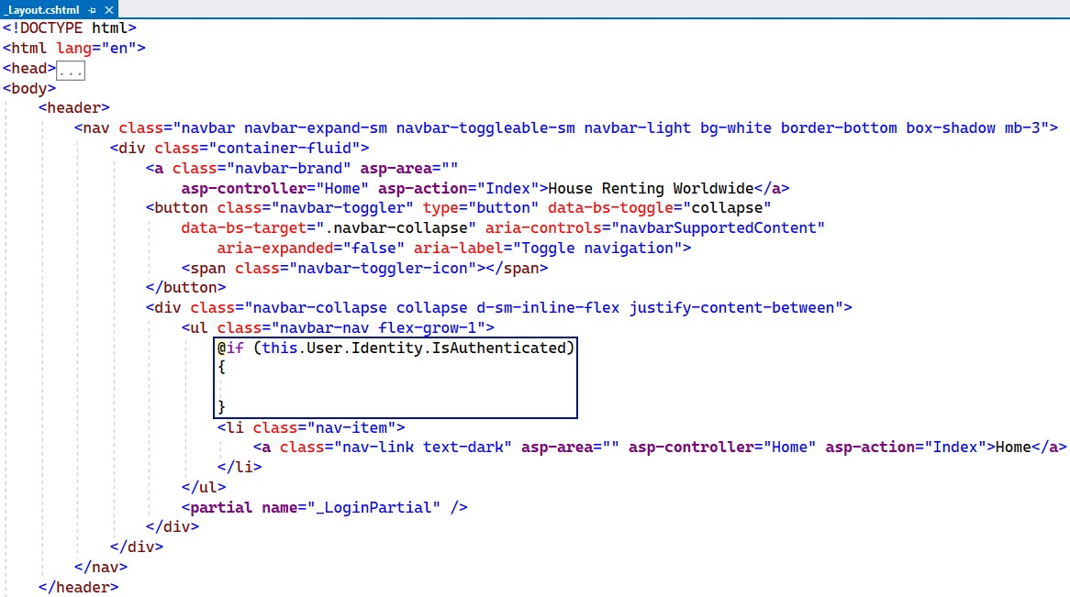

Then, outside of the **if** **statement**, add the "**All** **Houses**" **page** **link**, as the page should be **accessible to anyone**. In the **statement**, add **links** to the "**My** **Houses**" and "**Add** **House**" **pages**, which are **only for authenticated users**. Use the **asp-controller** and **asp-action** **tag** **helpers**, so that **links point to the correct controller action**. Don't forget to remove the link to the "**Home**" page.

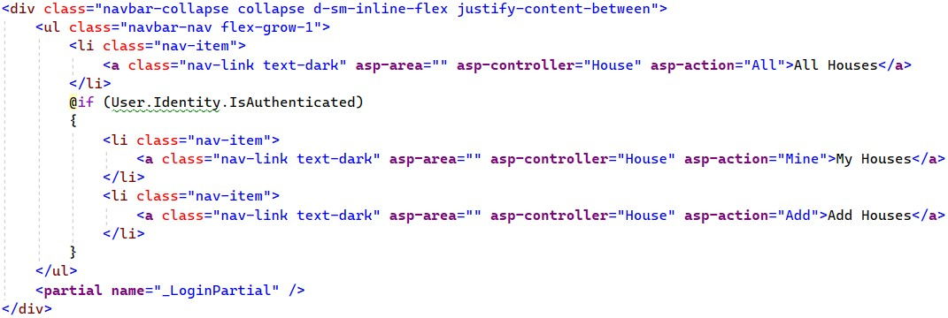

Now go to the **"_LoginPartial.cshtml"** **view** to add the "**Become** **Agent**" **page link**. It should be **only for loggedin** **users** (later we will see how only non-agents to see it), so find the right place in the view code and **add a link** like this:

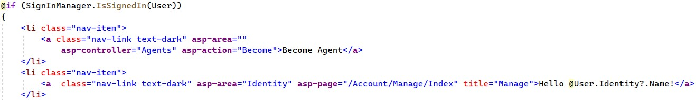

Try out the **navigation bar links** in the browser – they should **redirect to the correct pages**.

# Create the MVC Structure of the App

In our "**HouseRentingSystem**" **app** we will have **three controller classes –** **HomeController**, **HouseController** and **AgentController**. Now we will just **create the controller actions** with the **attributes** and **models** they need, but we **won't implement them** yet, as we will do this later in the workshop.

## Step 1: Modify the HomeController Class

We already have the **HomeController** in our **project** but we will modify it a bit, as we want it to **return a model**.

Start by creating a "**Home**" **folder** in the "**Models**" **folder** of our project – this is where the **models** for our **HomeController** should be created. Then, create the **IndexViewModel** **class** in the "**/Models/Home**" **folder**.

Use the **model** and **pass it to the view** in the **Index()** **method** of the **HomeController** **class**:

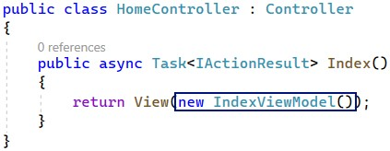

Now we should go to the **"Index.cshtml"** **view** in the "**/Views/Home**" **folder** and modify it to **accept an** **IndexViewModel**.

Before we write in the **view**, we need to go to the "**_ViewImports.cshtml"** **file** and **add the** "**HouseRentingSystem.Models.Home**" **namespace**, so that the **views can use the models** in our

"**/Models/Home**" **folder** like this:

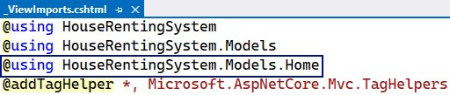

Add the **IndexViewModel** to the **"Index.cshtml"** **view** like this:

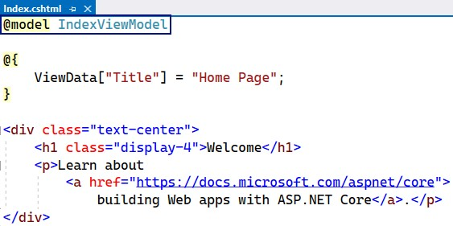

## Step 2: Create the HouseController Class

The **HouseController** will have all **actions** for **CRUD** **operations** on **houses** and **their renting**.

First, create the **HouseController** **class** in the "**Controllers**" **folder** of the "**HouseRentingSystem**" **project**.

The class should have some **methods,** which (for now) we will create **without implementing them fully**.

Start with writing the **All()** **method**, which should **return a view** with **all houses**. Create the **AllHousesQueryModel** **model**, which will later get information from the **request query** and use it to generate a **view**, in the "**Models**" **folder**. Create a "**Houses**" **folder** for **house models** and **add the above model class**.

We will leave the **model class** like this for now and **add properties** **later**. Go back to the **HouseController** and write the **All()** **method** to **return a view** with the newly-created **model**.

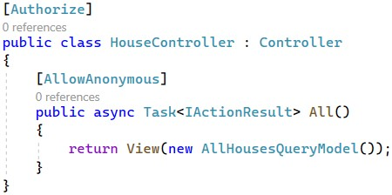

As the actions returns a view, let's **create that view**. To do this, create a "**Houses**" (the name of the **controller**) **folder** in the "**Views**" **folder** of the project and then **create an empty** **Razor** **view** named **"All.cshtml"** (the name of the **action**).

Before we write in the **view**, we need to go to the **"_ViewImports.cshtml"** **file** and **add the** "**HouseRentingSystem.Models.Houses**" **namespace**, so that the **views can use the models** in our "/**Models/Houses**" **folder**.

Now, in the **All** **view**, use the **@model** **directive**, which specifies what **type** the view should accept from the **controller** **action**. In this case, we accept a **AllHousesQueryModel** **model**:



Then, we will **set a page title** with **ViewBag** and then use it in a **page heading**. For the **ViewBag**, we will use the **@** **symbol** to **open a code block** and **write C#** in it like this:

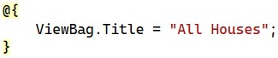

The rest of the **"All.cshtml"** **file** looks like this:



We will improve it later in the workshop.

Go back to the **HouseController** **class** and continue with writing its **methods**. The next **action** is **Mine()**, which should also **return a view with houses**. Use the **[Authorize]** **attribute** to make the method accessible only for **authorized users**:

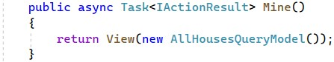

The **method** uses the **AllHousesQueryModel** **model**, which we have created already. **Create a view**, similar to the one we just created, which will be returned:

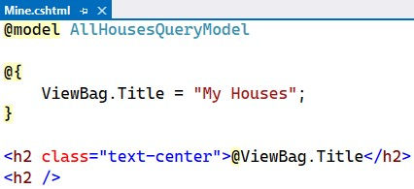

Next, add the **Details(int** **id)** **action** to the **controller class**, which should **return a view** with a **details model**:

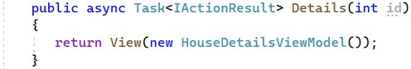

Create the **HouseDetailsViewModel** **class** in the "**/Models/Houses**" **folder** and **leave it empty** for now. Then, **write the method** to return a **view** and **create the view**, as well. The **view** should be the following:

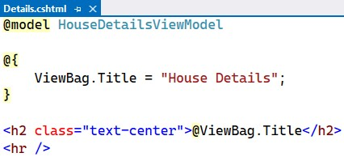

In the **HouseController**, add the **Add()** **method**, which should just **return a view**. Remember that only **authorized users** should be able to access the "**Add** **House**" **page**:

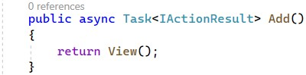

The **"Add.cshtml"** **view** should **contain a form for adding a new house**. However, we will **create the form later –** for now, the **view** should be the following:

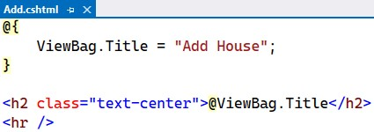

Next, write the **Add(HouseFormModel** **house)** **method**, which should **accept a model** from the **view** when we **create its form**. Create the **HouseFormModel** **class** in the "**/Models/Houses**" **folder** and **leave it empty** for now.

The **Add(HouseFormModel** **house)** **method** should be invoked on a "**POST**" **request** and be for **authorized users** only:

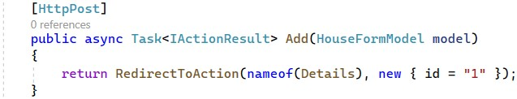

The method should **add a new house** to the **database** (which we will do later) and **redirect the user** to the "**House** **Details**" **page** of the **newly-created house**. The **Details(int** **id)** **controller** **action** accepts an **id**, but we will **hardcode** it for now.

Next **methods** to be implemented are for the "**Edit** **House**" **page**. The method on a "**GET**" **request** should accept a house **id**, so that we know which **house to edit** and **return a view** with the **current house information**:

The **method** for the "**POST**" **request** to the "**Edit** **House**" **page** should accept a house id and a **model** and **redirect** the user to the "**House** **Details**" **page** after the house is **modified in the database**:

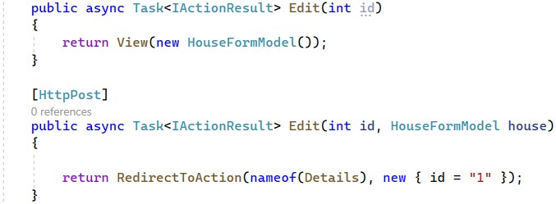

The **methods for** **deleting a house** are similar to the above methods, but they **accept** and **pass** a **HouseDetailsViewModel** **model**. After the **house is deleted**, the user should be **redirected** to the "**All** **Houses**" **page**. Write them like this:

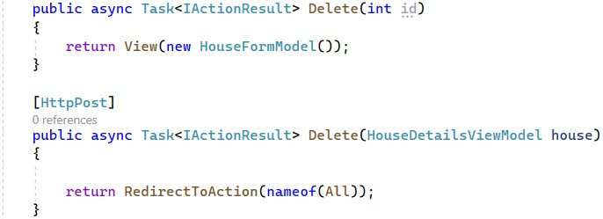

Create the **"Edit.cshtml"** and **"Delete.cshtml"** **views**, as we did with the previous ones:

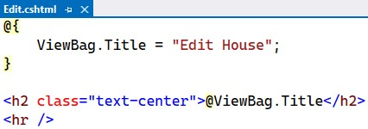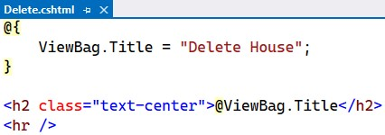

Finally, write the **methods** for the **house renting and leaving functionality**. They should be invoked on a "**POST**" **request** and **redirect** the user to the "**My** **Houses**" page:

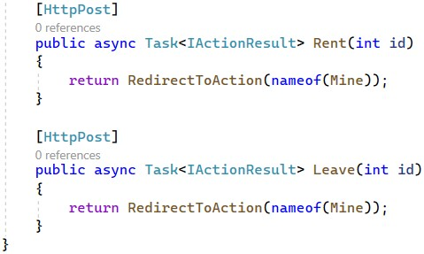

## Step 3: Create the AgentController Class

The **AgentController** is taking care of the **agents functionality**.

Create the **AgentController** in the "**Controller**" **folder** and write the **Become()** **method** like this:

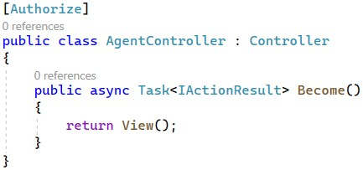

Create the **"Become.cshtml"** **view** in "**/Views/Agents**":

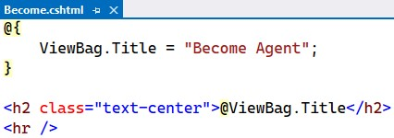

For the **Become(BecomeAgentFormModel** **agent)** **method** you should create the **BecomeAgentFormModel** in the "**/Models/Agents**" **folder**.

Write the **method** to be **invoked** on a "**POST**" **request** and **return a redirect response**:

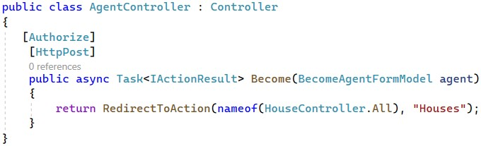

Now we have written the **structure of our controllers** (**HomeController**, **HouseController** and **AgentController**) and their **actions**, as well as the **models** and **views** for our **MVC app**.

In the next task, we will start creating **services**, which will contain the **app's business logic** and **interact with the database**. Our **controllers** will use the **service methods** and depend only on them – they will **not have access to the database**. We will do this by creating **services with service models** and implementing the **logic in service methods**. Let's see how this is going to happen.

# Implement the "Home" Page

The "**Home**" **page** of the app should always **show the last three added houses** as a **slideshow**:

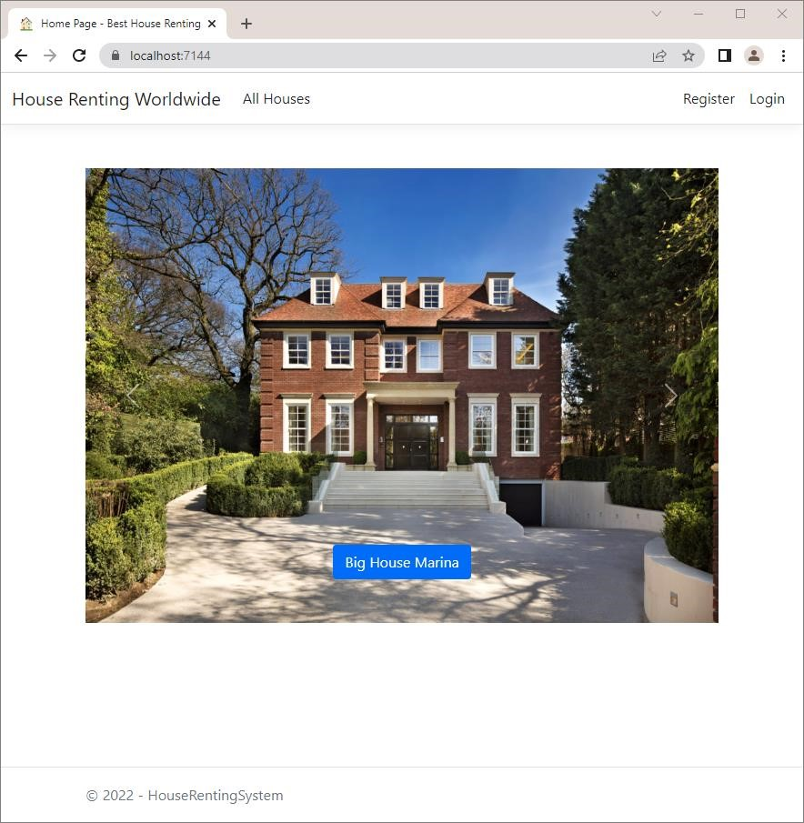

If there **aren't any houses**, the "**Home**" **page** should look like this:

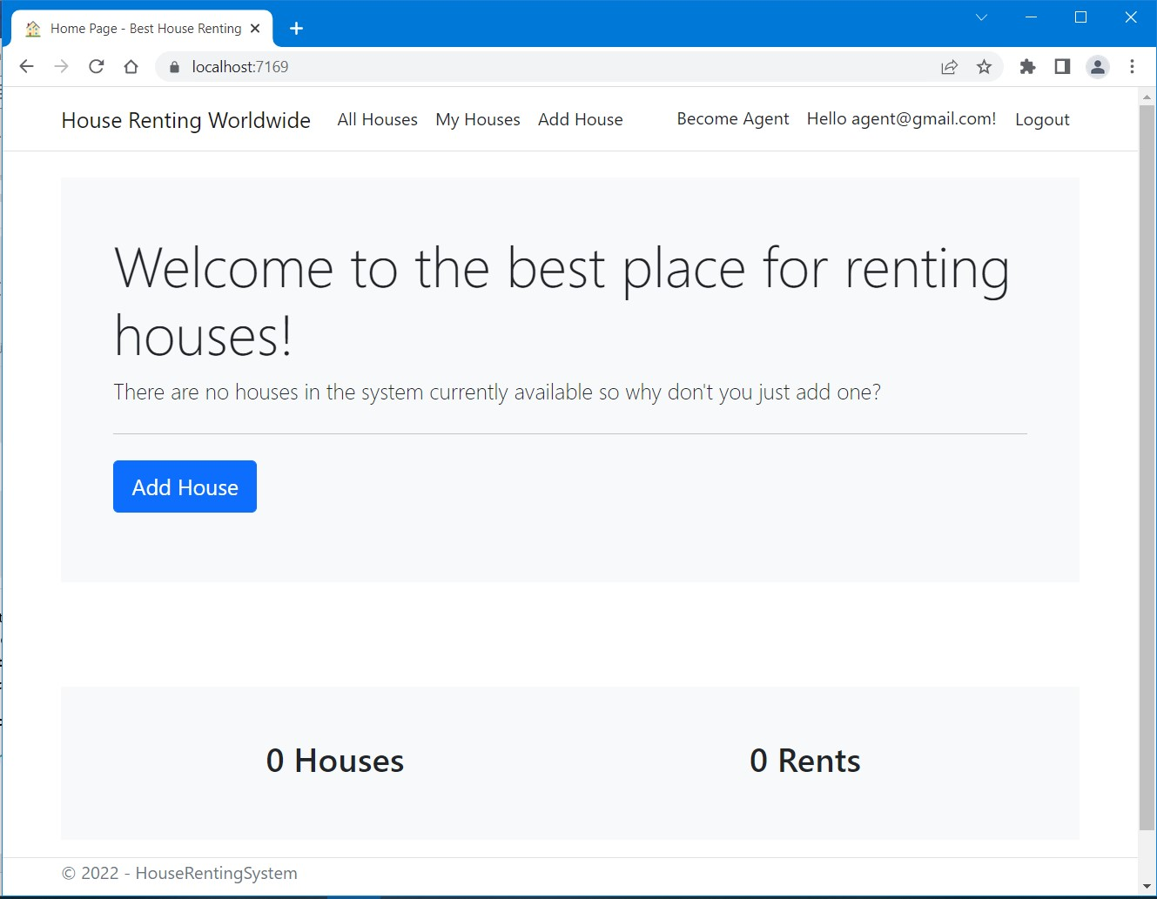

First, we should create two additional folders in our project – "**Contacts**" and "**Services**". They will hold the **interfaces** and the **services** classes.

The "**Home**" **page** is accessed on "**/**" and **invokes** the **Index()** **method** of the **HomeController** **class**. We should **modify** the **HomeController** class with its **Index()** method to use services. The **houses** **collection** for the **view** (for the houses slideshow) will be implemented by using a **service method** in the **HouseService** **class**. The **total houses and total rents counts** will be obtained in a **separate API controller** with a **separate service class** (you will see how to do this on the next task).

For now, create an **IHouseService** **interface** in the"**Contracts/House"** and a **HouseService** **class** in the "**Services/House**" folders.

Then, we should define the following **method** in the **IHouseService** **interface**, which should only **return a collection** with the **newest three houses** from the **database**:

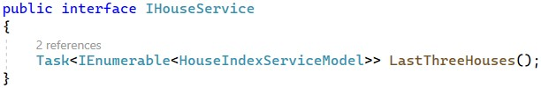

Create a new model **HouseIndexServiceModel** to be returned by the **service method**:

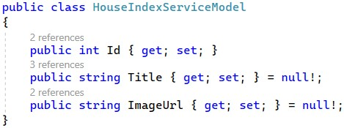

**Implement** **the method** from the **IHouseService** **interface** in the **HouseService** **class**.

Don't forget to inject the **HouseRentingDbContext** through the constructor and assign it to a variable to use it. After that, we will **chain several methods** to **extract what we need from the database** and use it. First, we should **get all houses** from the database and then **get the newest houses** first by **sorting** **them** **by id in descending order** (newer houses have a higher id). Using the the **Select()** **LINQ method** and **project** **the House entities** to **HouseIndexServiceModel**, as we should **pass** **view models to the view**. Make sure you fill in all the **HouseIndexServiceModel properties** with **correct data** from the **database**. Finally, we take the first three **house models.**

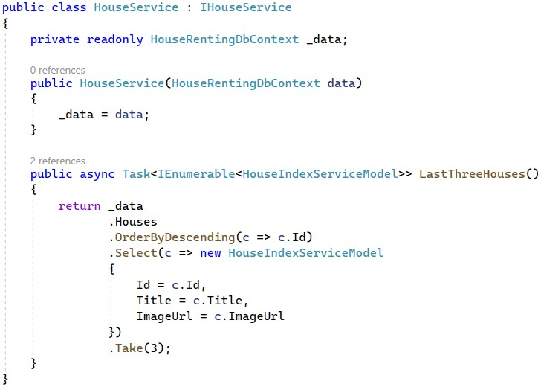

It's very important to remember to go to the "**Program.cs**" file and add the service like this:



We set the **service** as **transient**, as we a **new instance to be created every time**.

At the end, **modify** the **HomeController** to use only the **IHouseService** **methods** and modify the **Index()** method. Don't forget to **inject the service through the constructor**, so that we can **use the service** **methods** when we create them. **Create a property** for the service and **set it**:

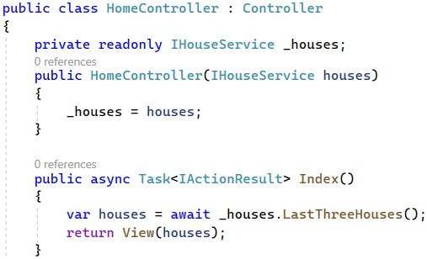

Now, we have to modify the "**Index.cshtml**" file and it should accept an

**IEnumerable<HouseIndexServiceModel>**.As the code is a lot, you can copy it from here:

|  |
| --- |
| @model IEnumerable<HouseIndexServiceModel>    @{  ViewData["Title"] = "Home Page"; var houses = Model.ToList();  }    @if (!houses.Any())  {  <div class="mt-4 p-5 bg-light">  <h1 class="display-4">Welcome to the best place for renting houses!</h1> <p class="lead">  There are no houses in the system currently available so why don't you just add one?  </p>  <hr class="my-4">  <p class="lead">  @if (User.Identity.IsAuthenticated)  {  <**a** **asp-controller**="House" **asp-action**="Add" class="btn btn-primary btn-lg"  role="button">Add House</**a**>  }  </p>  </div>  }    <div class="mb-5"></div>  <div id="carouselExampleControls" class="carousel slide" data-bs-ride="carousel">  <div class="carousel-inner">  @for (int i = 0; i < houses.Count(); i++)  {  var house = houses[i];  <div class="carousel-item @(i == 0 ? "active" : string.Empty)">  <img class="d-block w-100" style="height:500px" src="@house.ImageUrl" alt="@house.Title"> |

<div class="carousel-caption d-none d-md-block">

<h5>

<**a** class="btn btn-primary" **asp-controller**="House" **aspaction**="Details"

**asp-route-id**="@house.Id"> @house.Title</**a**>

</h5>

</div>

</div>

}

</div>

<button class="carousel-control-prev" type="button" data-bstarget="#carouselExampleControls" data-bs-slide="prev">

<span class="carousel-control-prev-icon" aria-hidden="true"></span>

<span class="visually-hidden">Previous</span>

</button>

<button class="carousel-control-next" type="button" data-bstarget="#carouselExampleControls" data-bs-slide="next">

<span class="carousel-control-next-icon" aria-hidden="true"></span>

<span class="visually-hidden">Next</span>

</button>

</div>

**Try** the "**Home**" **page** in the browser. You should see the **last three houses in a slideshow**.

# Implement Agents

Our next step is to implement the Agents pages, services and functionalities.

The user should **access** the "**Become** **Agent**" **page** on "**/Agents/Become**" (only for **authorized users**, who are **not agents**). It should look like this:

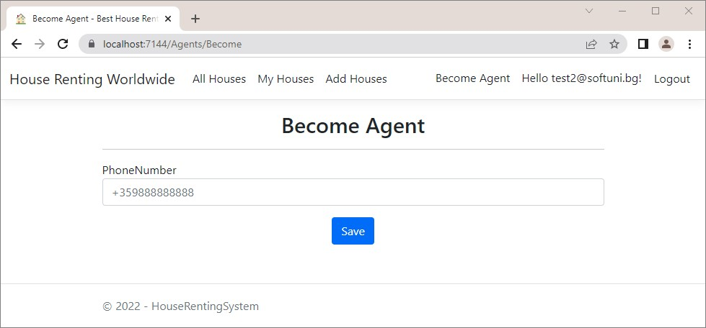

Let's start by creating an "**Agent**" **folders** with an **IAgentService** **interface** and a **AgentService** **class** in it. Note that the **AgentService** **class** should **inherit** **IAgentService**.

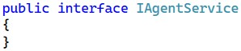



Now go to **Program.cs** and **add the service** like this:



Now go to the **AgentController** and **inject the service through the constructor**, so that we can **use the service** **methods** when we create them. **Create a property** for the service and **set it** like this:

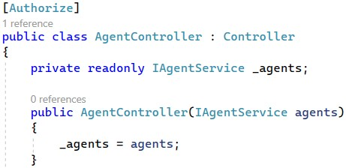

We want to **write the business logic in a service method**. Start with the **Become() controller method** – we want it to **invoke a service method** to **check whether the currently logged-in user already** **exists as an agent**. The **service method**, on the other hand, will **accept parameters** from the controller action and use them to **return a result**.

Go to the **IAgentService** **class** and **declare a method**, which accepts an **user id** and **returns a bool**, depending on whether an **agent with the user id exists**:

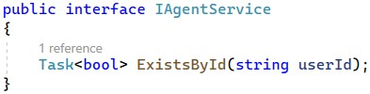

Now **implement the method** in the **AgentService** **class**. Before that, however, we need to **add** the **db** **context** **through the constructor** and **assign it to a property**, so that we can **obtain data from the database**. Do it as shown below:

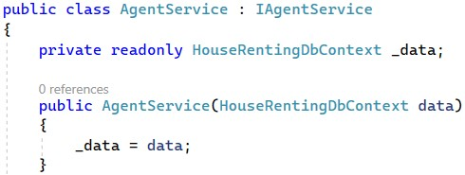

Write the **logic** for the **method** like this:

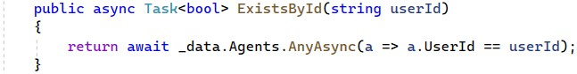

Go to **AgentController** and **modify** the **Become()** **method** to **use the service**:

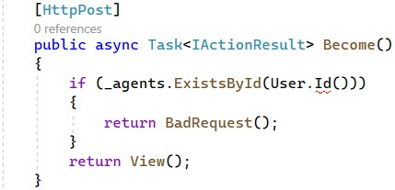

As you can see, the **ClaimsPrincipal** does not contain a definition for **Id**, so we'll have to add it. To **get the current** **user id**, let's create a **separate class** called **ClaimsPrincipalExtensions** in a **new folder** "**Infrastructure**". The reason for this is that we will need the **id** in **several classes** and want our code to be reusable. We named the **ClaimsPrincipalExtensions** **class** like this because it will **extend** the **ClaimsPrincipal** **class**, which supports **mu**ltiple **claims-based identities** (e.g. user information).

Write a method for **getting the current user id** in the class like this:

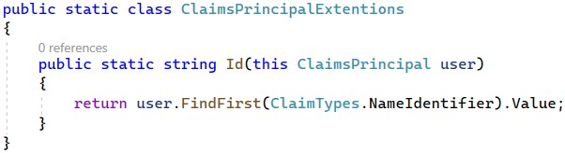

Now let's use **service methods** in the **Become(BecomeAgentFormModel** **model)** **controller method**, as well. In it, we **check whether the current user exists as an agent**, **whether an agent with a phone number exists** and whether the **user has any rents in the system**. Then, we create a **new** **Agent** **entity** and **save it to the database**.

Go to the **IAgentService** **class** and **define methods** for the above functionalities:

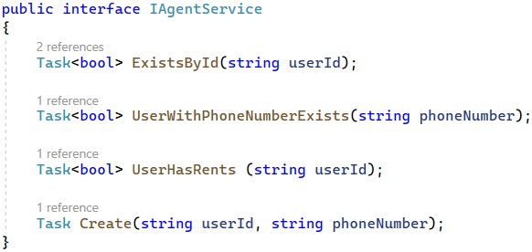

**Implement the methods** in the **AgentService** **class** like shown below. First, we need to check if the **current user is not already an agent**. This is done again for more security. Then we check if the user has any rents and if another agent with that phone number exists.

Next, after we are sure that we have **valid data from the model**, we will create the **Agent**. To do this, we should first **get the current user id**, as our **Agent** **class** has a **UserId** **property**. Then we **add the new Agent record** to the **database** through the **db** **context** class. Don't forget to **save the changes**. Do it like this:

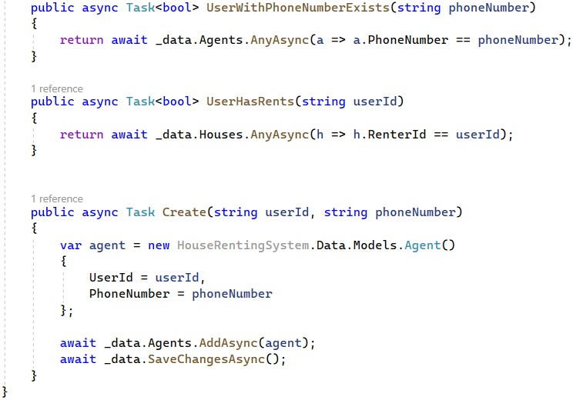

**Before using these methods in the Become(BecomeAgentFormModel** **model)** **method** in the **AgentController** **class**, we should write the properties for the **BecomeAgentFormModel** that we have already created.

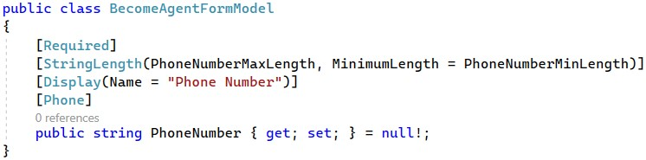

The returned **view** will be "**Become.cshtml**". In it, our model properties names will be displayed as they are in the model class. We don't want to have a "**PhoneNumber**" **label** on the "**Become** **Agent**" page. It should be "**Phone** **Number**".

For this reason, we will **add the** **[Display(Name** **=** **"")]** **attribute** over the **BecomeAgentFormModel** **class** **property PhoneNumber** to **set its display name in views**.

Now that we have our model, we can use **the methods** in the **Become(BecomeAgentFormModel** **model)** method in the **AgentController** **class**. First, we need to check again if there is a **user with the** **id** of the **current user** as a **UserId**, this means that the **current user is already an agent** and a **BadRequest** should be returned and if the current user is **not an agent**, a **view** should be returned.

We have to **add some other validations** for **becoming an agent**, using the **ModelState** **class**. If a user tries to **become an agent** with a **phone number of another agent**, we should display an **error**. Also, a **user** **should have** **no current rents** to become an agent. Then, the **ModelState.IsValid** check will make sure that the **error is displayed in the browser**.

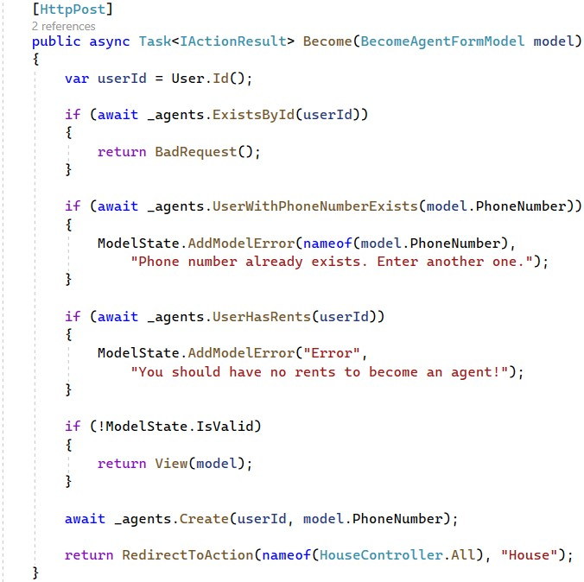

Now let's create the "**Become** **Agent**" **form** in the view, so that the **user can send data** to the app.

In MVC, **controllers pass a model to the views** if views need its data. Then, **views display model data** or (if there is a form in the view) **send a model** filled with submitted data to the **controller**. In our case, the **Become** **view** should have a **form for submitting a phone number**, which will be used to populate the **BecomeAgentFormModel**. The **BecomeAgentFormModel** will be then **returned to the controller**.

To use the **BecomeAgentFormModel** in the "**Become.cshtml"** **view**, add it like this:

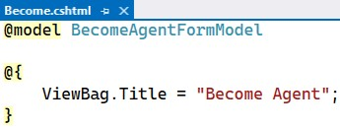

Then, **add a form** with an **input field** for the **PhoneNumber** **property** of the **model class**. Use the **asp-for** **input tag** **helper** to bind an **HTML** **<input>** **element** to a **model property** in your **Razor view**:

You can get the code from here as it is a lot to write:

|  |
| --- |
| @model BecomeAgentFormModel    @{  ViewBag.Title = "Become Agent";  }    <h2 class="text-center">@ViewBag.Title</h2>  <hr />  @if (!ViewData.ModelState.IsValid && ViewData.ModelState["Error"] != null) {  <div class="alert alert-danger" role="alert">  @ViewData.ModelState["Error"].Errors.First().ErrorMessage </div>  }    <div class="row">  <div class="col-sm-12 offset-lg-2 col-lg-8 offset-xl-3 col-xl-6">  <**form** method="post">  <div class="form-group">  <**label** **asp-for**="PhoneNumber"></**label**>  <**input** **asp-for**="PhoneNumber" class="form-control" placeholder="+359888888888">  <**span** **asp-validation-for**="PhoneNumber" class="small textdanger"></**span**> </div>  <div class="text-center">  <input class="btn btn-primary mt-3 " type="submit" value="Save" />  </div>  </**form**>  </div>  </div>    @section Scripts {  <**partial** **name**="_ValidationScriptsPartial" />  } |

Note that we use the **asp-validation-for** **tag helper** to **apply the model property restrictions** directly to the **form field**. For example, the **[PhoneNumber]** **attribute** over the **PhoneNumber** **property** in the **BecomeAgentFormModel** will validate that the form field has a **valid phone number**.

At the end, we will **define a section** in our Become **view**, which will **invoke** the

"**_ValidationScriptsPartial.cshtml**" **partial view**. It checks whether the **entered form data is valid** **before the form is submitted**. We will see how this is done later.

Also, note that we give a **custom name** to the **model error**, as it is not connected to a property. For this reason, we should also go to the **"Become.cshtml"** **view** and **modify it to display the error**, as it won't do it by itself.

We have the first functionality in our app – the one for **becoming an agent**. Test it by **registering** or **logging** in the app and accessing "**/Agents/Become**". Examine the "**Become** **Agent**" **page functionality** in the browser. The page should **work** **correctly**. Try to **become an agent with user**, who is **already an agent**, and with one, **who is not**. Try to **fill an invalid phone number** – an **error** should appear:

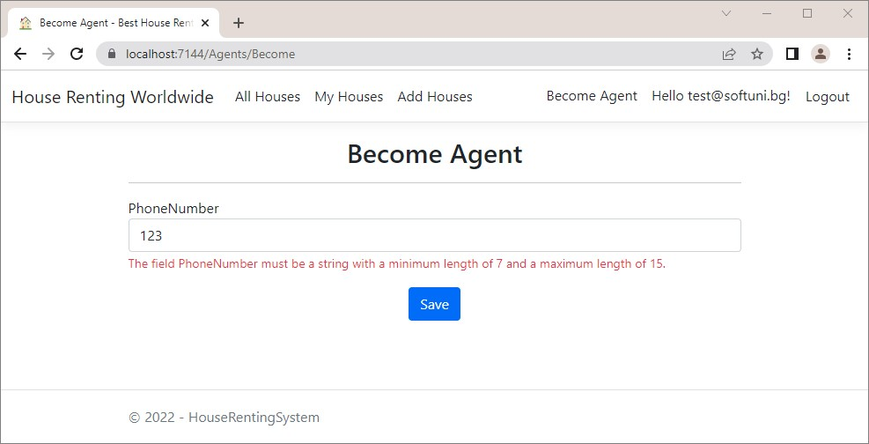

Then, **fill in a valid phone number**. You should be **redirected** to the "**All** **Houses**" **page** after **pressing** the **[Save]** **button**. When you are **already an agent** and you try to **access** the "**Become** **Agent**" **page** again, a **BadRequest** will be returned:

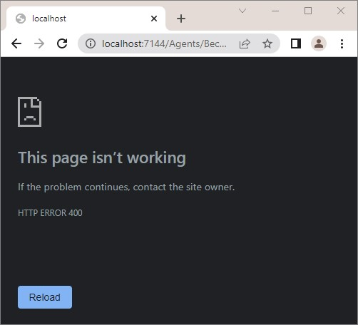

Look at the "**Agents**" **table** in the **database** in **SQL** **Server** **Management** **Studio**. It should have the new **Agent** **record**:



# Implement "Add House" page

Now it's time to implement the "**Add** **House**" **page** on "**/House/Add**" (only for **authorized users**, who are **agents**).

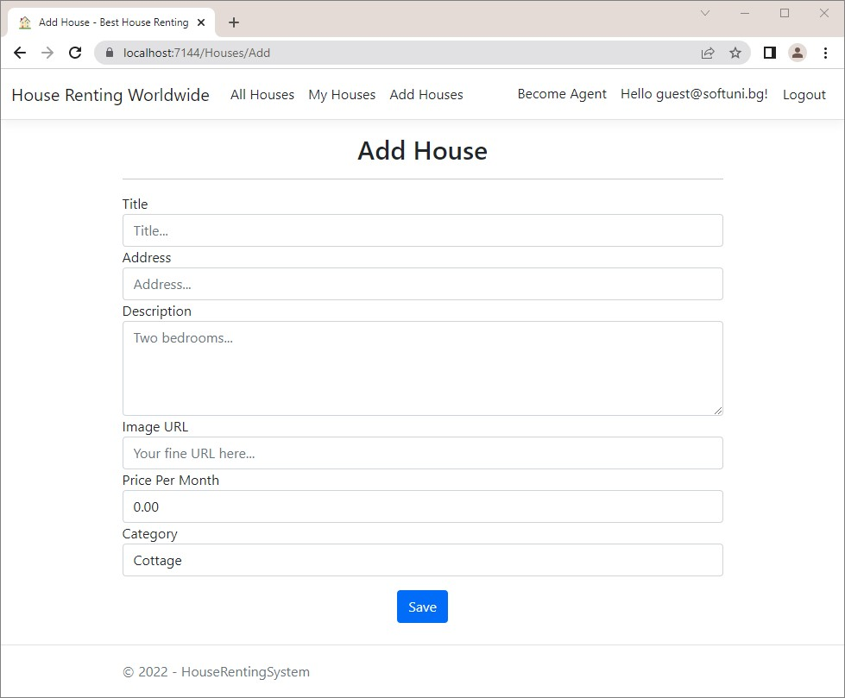

The user should **fill in the** "**Add** **House**" **form** with **valid data**, **choose a category** and press **[Submit]**. Note that available **categories should be displayed in the dropdown menu** like this:

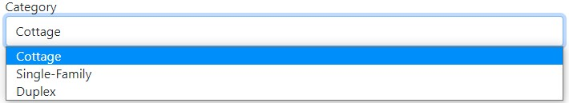

The **form data** should be used for creating a new **House** **record** in the **database** and the user should be **redirected** to the "**Details**" **page** of the **newly-created house**.

The methods, which implement the above functionalities, are the **Add()** and **Add(HouseFormModel** **model)** **methods** in the **HouseController** **class**. Before we modify the **controller actions**, we have to **inject the service**:

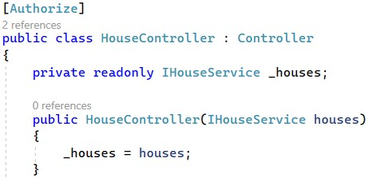

For this controller action, we need to **add a single service method** to **get all categories from the database** and **return them as a collection**.

First, let's create the **HouseCategoryServiceModel** in the "**/Services/Houses/Models**" **folder** for the service, because we'll need it in a few minutes. It should look like this:

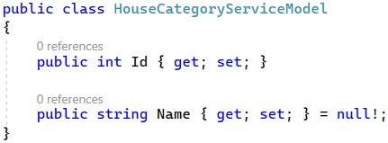

Now we should modify the HouseFormModel, as well. This class should have **properties** for **title**, **address**, **description**, **image** **URL**, **price** **per** **month**, **category** **id** and a **collection for categories**. As this is a model for **submitting a form**, we should **add restrictions** for **min** and **max length**, **range**, etc.

Use the **[StringLength(…,** **MinimumLength** **=** **…)]** **attribute** to **set max and min length** of the **Title**, **Address** and **Description** **properties**. The **constants** for **min lengths** are part of the **DataConstants** **class**, that we have already created. Don't forget that you should add the **[Required]** **attribute** over **obligatory properties**. The **ImageUrl** **property** should also have that **attribute**. Next, **restrict** the **PricePerMonth** **property** to have **values between 0 and 20000**. To do this, use the **[Range]** **attribute** and **add the min and max values**. Also, add a **custom error message** so that it is more user-friendly. Finally, add the **CategoryId** **property**, which holds the **selected category id**, and a **collection of category models**, as the user should have the **categories to choose from**.

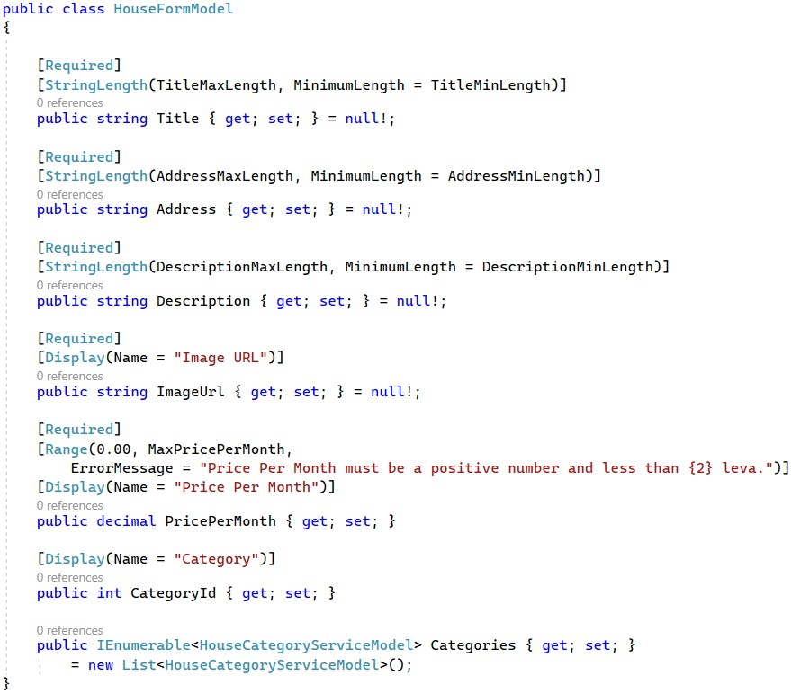

Now, implement the **service method** for **getting all categories** like this:

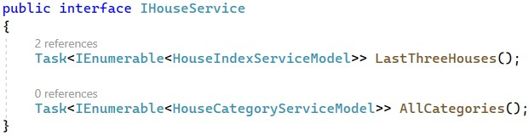

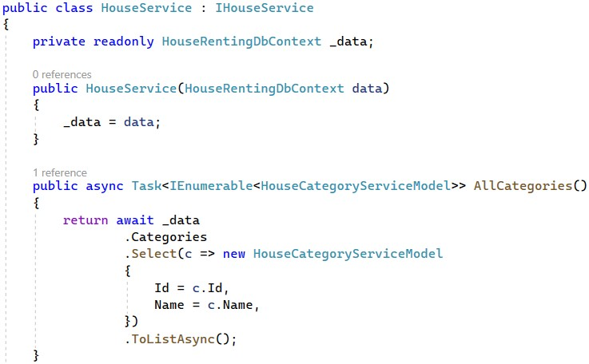

Now it's time to modify the **Add()** method in the **HouseController** in order for it to use the above methods. It should look like this. In our app, **only agents are allowed to add houses**, so check if the **current** **user is an agent**. If they are not, **redirect** them to the "**Become** **Agent**" **page**:

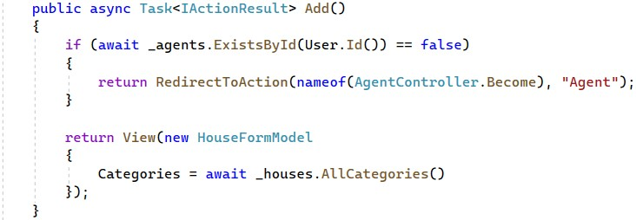

Don't forget to **accept the** **IAgentService** **through the constructor**:

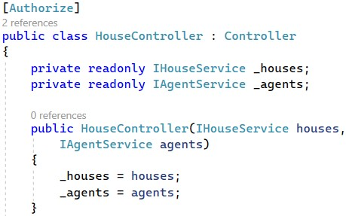

Now we should **modify** the **Add(HouseFormModel** **model)** **method**. For it, we need to **create service methods** to **check whether a category with a given id exists** and to **create a new House entity in the database**.

**Implement** the following methods in **IHouseService** and **HouseService** **classes**:

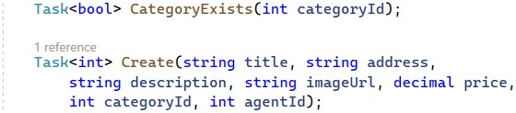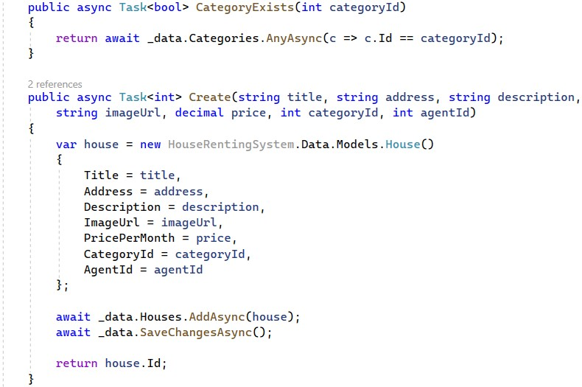

As you can see, the **Create(…)** **service methods** returns the **new house id** because our **controller** needs it. The **Add(HouseFormModel** **model)** **controller** **methods** should **use service methods** as shown below:

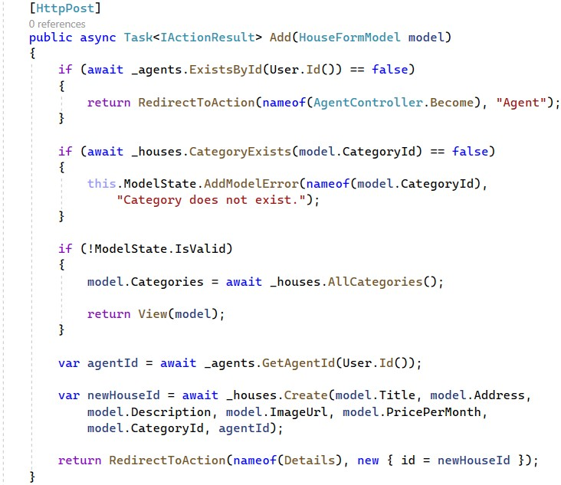

You can see that our **IAgentService** interface doesn't have a **GetAgentId method,** so our next task is to **implement** it**.**

Go to the **IAgentService** and write it:

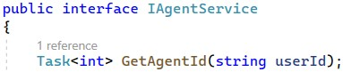

Next, go to the **AgentService** class and write the **service method**:

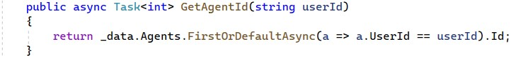

The last for completing this functionality is implementing the view. We have already created the **"Add.cshtml"** file in the **/Views/Houses** folder. We have to **add** the **HouseFormModel** to the view.

Then, we should **add the form**. However, we will **reuse this form** for the "**Edit**" **functionality** later. For this reason, we will create a **partial view**, called **"_HouseFormPartial.cshtml"**, where we will **keep the form**.

In the **Add** **view** you should just **render the partial view** with the **HouseFormModel** and at the end, don't forget to **render** the **_ValidationScriptsPartial**, as well, because we have a **form to be checked**:

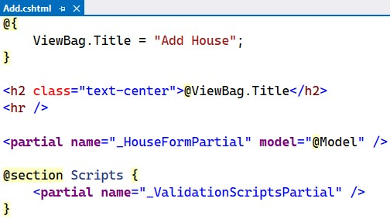

Create the **"_HouseFormPartial.cshtml"** **partial view**. To do this, **right-click** on the "**/Views/House**" **folder** and on **[Add]** → **[View]** and **choose** **[Razor** **View]**:

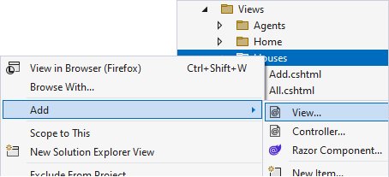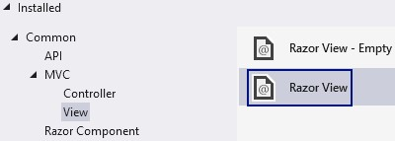

On the next window, **fill in the view name** and **check** "**Create** **as** **a** **partial** **view**":

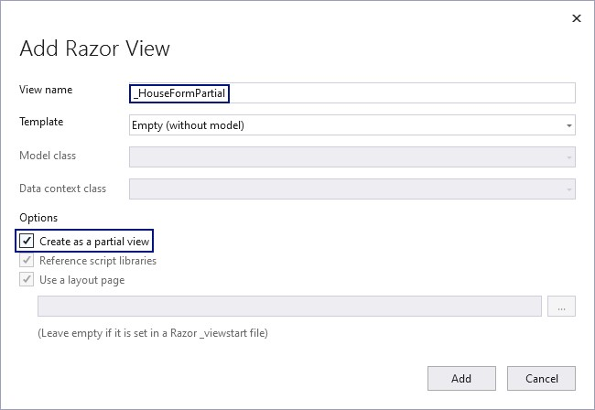

The **new partial view** should first accept a **HouseFormModel** from the **view** that **renders** it. As the code is a lot to write, you can copy it from here:

|  |
| --- |
| @model HouseFormModel    <div class="row">  <div class="col-sm-12 offset-lg-2 col-lg-8 offset-xl-3 col-xl-6">  <**form** method="post">  <div class="form-group">  <**label** **asp-for**="Title"></**label**>  <**input** **asp-for**="Title" class="form-control" placeholder="Title...">  <**span** **asp-validation-for**="Title" class="small text-danger"></**span**> </div>  <div class="form-group">  <**label** **asp-for**="Address"></**label**>  <**input** **asp-for**="Address" class="form-control" placeholder="Address...">  <**span** **asp-validation-for**="Address" class="small text-danger"></**span**> </div>  <div class="form-group">  <**label** **asp-for**="Description"></**label**>  <**textarea** **asp-for**="Description" rows="4" class="form-control" placeholder="Two bedrooms..."></**textarea**>  <**span** **asp-validation-for**="Description" class="small textdanger"></**span**> </div>  <div class="form-group">  <**label** **asp-for**="ImageUrl"></**label**>  <**input** **asp-for**="ImageUrl" class="form-control" placeholder="Your fine URL here..."> |
| <**span** **asp-validation-for**="ImageUrl" class="small textdanger"></**span**> </div>  <div class="form-group">  <**label** **asp-for**="PricePerMonth"></**label**>  <**input** **asp-for**="PricePerMonth" class="form-control"> <**span** **asp-validation-for**="PricePerMonth" class="small textdanger"></**span**> </div>  <div class="form-group">  <**label** **asp-for**="CategoryId"></**label**>  <**select** **asp-for**="CategoryId" class="form-control">  @foreach (var category in Model.Categories)  {  <**option** **value**="@category.Id">@category.Name</**option**> }  </**select**>  <**span** **asp-validation-for**="CategoryId" class="small text-  danger"></**span**> </div>    <div class="text-center">  <input class="btn btn-primary mt-3" type="submit" value="Save" />  </div>  </**form**>  </div>  </div> |

Note that we used a **foreach** **loop** in a **Razor view** to iterate through the **Categories** **collection** in the **model**. Also, look at the **<label>** **tags** of the **form** – they use the **class property name**. However, our properties have names like "**ImageURL**", "**CategoryId**", etc., which should **not be displayed** like that. That is why we used the **[Display(Name** **=** **"")]** **attribute** over some of the **HouseFormModel** **class** **properties**.

Now it's time to test the "**Add Houses**" functionality. Register and log in in the app with a user that is not yet an **Agent**. Go to the "**Add Houses**" page and you should be redirected to the "**Become Agent**" page as adding houses can be performed only by agents. Modify your account to become an agent and try again the "**Add Houses**" – you should see the "**Add Houses**" page.

Try filling in some **invalid data** – you should see that **errors appear**. Then, **fill in valid data** and you should be **redirected** to the "**Details**" **page** **of the new house**:

You can get the above image URL from here:

<https://i.pinimg.com/originals/62/6b/5a/626b5ab0ca1dc5eb033dfaf2d8254ca0.jpg>

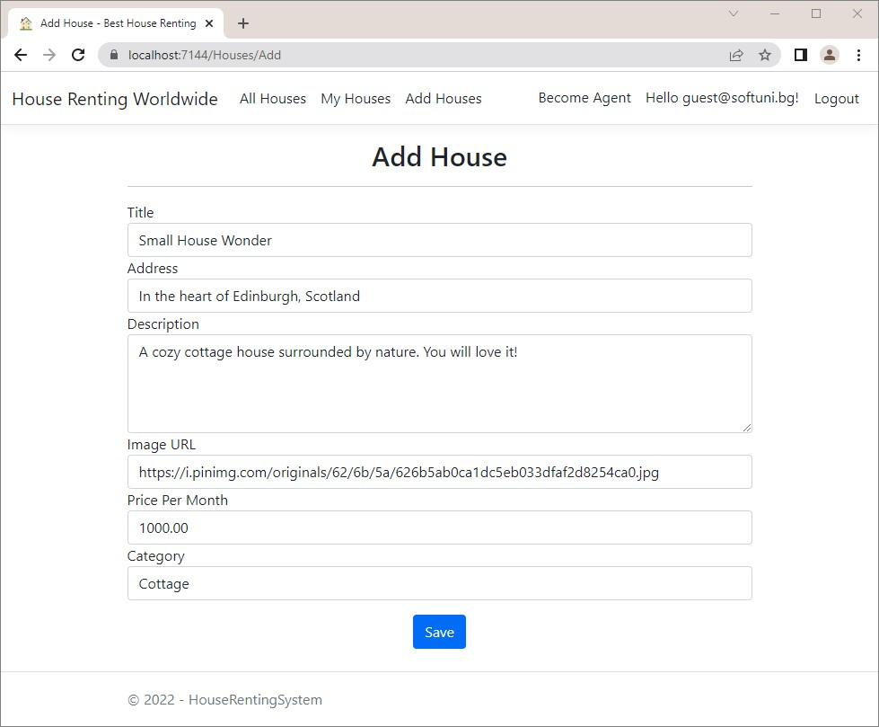

Upon pressing the [**Save**] button, you are redirected to the "**House Details**" page, but we have not yet implemented this functionality. We will do this later in the workshop, because first we must implement the "**All Houses**" page, which will give us access to the "**Edit** **House**" and "**Delete House**" functionalities.

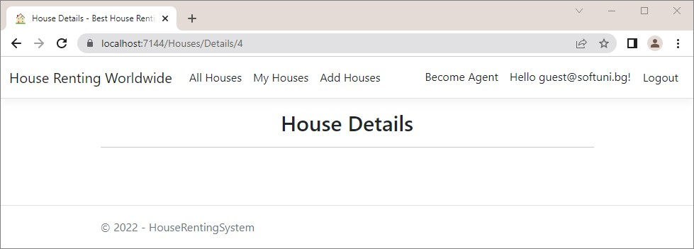

Before that, look at the **new house** in the "**Houses**" **table** of the **database** and make sure it is there.

# Implement "All Houses" page

Let's start implementing the "**All Houses**" page. It should **display the houses from the database** and **implement searching**, **sorting** and **paging** **functionalities**. It should look like this:



Start with the **All([FromQuery]** **AllHousesQueryModel** **query)** **controller method** – we want it to **invoke a service method** and **pass the result model to a view**. The service method, on the other hand, will accept **parameters** **from the** **controller action** and use them to **return a model**.

We want to create the following **workflow** in our app:

* The **controller** **accepts a model** from the **query string**
* It invokes a **service method** to **get the houses and their count** as a **model**
* Invokes a **service method** to **get the house categories**
* Updates the **query model's** houses, houses count and categories
* Passes the model to the **view**

First, let's add an **enum** **class** for the **house sorting**. Create the **HouseSorting** **class** in the "**Infrastructure**" **folder**. The class should have the **options for sorting** – we can **sort houses by newest**, by **price** or by **not-rented first**. The **enum** **class** looks like this:

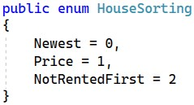

Now, to implement the above-described **workflow** in the controller method, let's first **create the service methods**. Go to the **IHouseService** **class** and **declare a method for getting all houses and their count** and one for **getting the house categories**.

The **All(…)** **method** in the **IHouseService** **class** needs a **category name**, a **search term**, a **HouseSorting** **value** and the **current page** and **houses per page values** to filter and return the correct houses. It should return a **model** **with the houses and their count**, called **HouseQueryServiceModel**.

Create the **HouseQueryServiceModel** in a separate **folder** called "**Models**" in "**/Services/Houses**" like this:

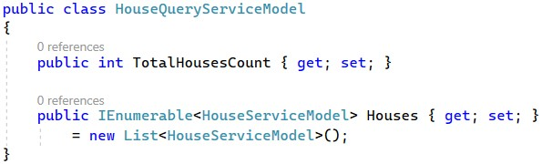

As you can see, we are going to need a **HouseServiceModel**, so go to the "**/Services/Houses/Models**"and **create** the **model.** It should look like this:

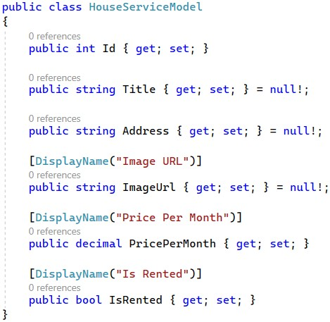

**Define** the **All()** **method** like this:

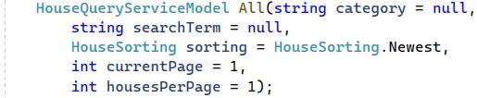

The **AllCategoriesNames()** method should **return all category names** as a **collection of string**:



Implement the **methods** in the **HouseService** **class**:

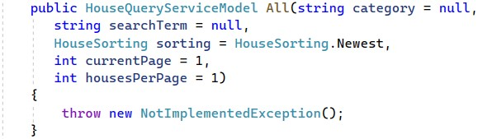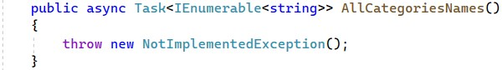

Now we should implement the **All(…)** **method**. Implement the logic for getting and filtering the houses to the **All(…)** **service method** like shown below.

We get the **houses from the model collection** and **convert** **it** to **IQueryable**, so that we can **perform LINQ operations** on it.

Then, we check whether we need to **filter houses by a category** and **get only the houses from the given category**. If we have a **search term**, we should get only the **House** **entities**, which **contain** it in their **title**, **address** or **description**. **Searching** should be **case-insensitive**.

It's time to do the **sorting**, too. If the user has chosen to **sort by price**, you should **order the collection in descending** **order by price**. If they have chosen to **sort by not-rented first**, you should **get the not-rented first**, then the **rented** **ones** and **sort them descending by id** (so that newer are first). If the user has chosen to **sort by newest** or **haven't** **chosen a sorting criterion**, **sort the houses by id** in **descending order**.

**Get the houses**, which are supposed to be on the **current user page**, get the **needed number of houses** and **project** them to a **List<HouseServiceModel>**. **Assign these houses** to the **Houses** **property** of the **current** **HouseQueryService model**. Then, **fill in the Categories collection** of the **model** with the **categories' names**, **without repeating** them.

Get the **total houses count** and **assign it**, as well.

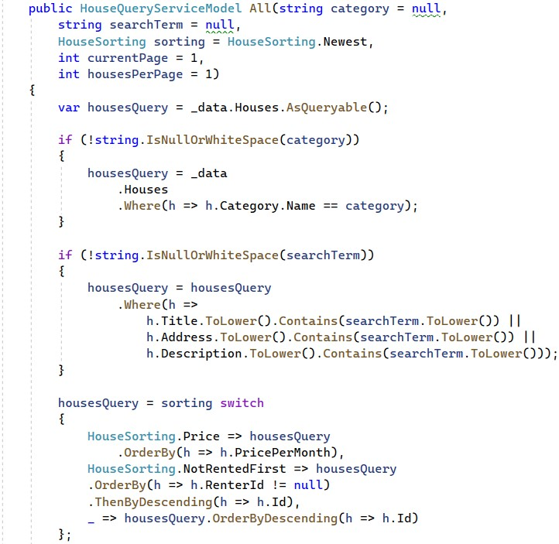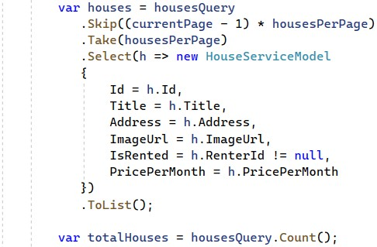

At the end, **return** a **HouseQueryServiceModel** with the **needed properties**:

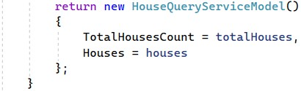

**Implement** the **AllCategoriesNames()** **method**, which should only **return the categories names**:

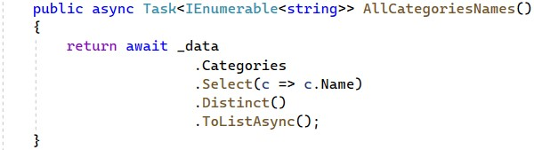

Now go to the **All([FromQuery]** **AllHousesQueryModel** **query)** **method** in the **HouseController** **class** and implement it to **use the service methods** we created and **return a view with the model:**

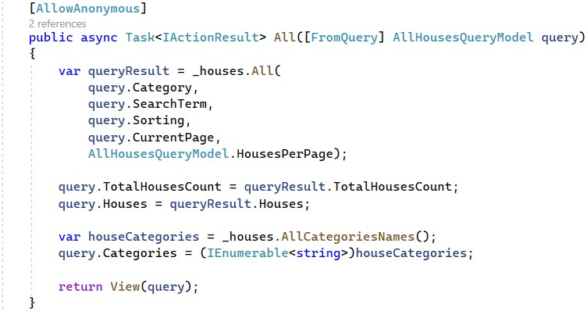

As you can see, we are using the **AllHousesQueryModel**. Go to the **model class** and **modify** it to look like this:

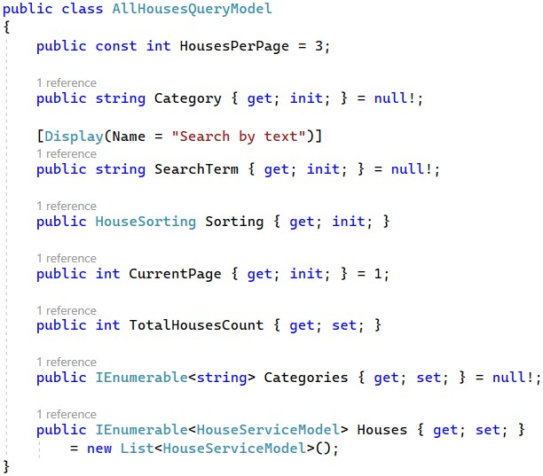

Now you should also go and **modify** the **"All.cshtml"** **view** to use the **HouseServiceModel**. **Import the service model class namespace** in the **"_ViewImports.cshtml"** **file** like this:

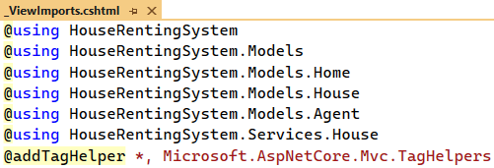

Now write the rest of the code for the "**All.cshtml**" view. We need to **create a form**, which will send a "**GET**" **request** when **submitted**. In this way, **model properties** will be **added as query parameters** to the **URL**. The **form** will look like this in the browser:

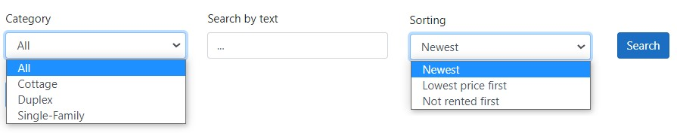

As you can see, we should **first add a dropdown menu** with the **categories** from the **model**. We should also **add the search term field** and the **sorting dropdown**. We should also add a [**Search**] button. We should also add to the view the **paging functionality**, which should have **buttons** for the **previous** **and next pages** (they should be **enabled**/**disabled**, depending on whether there are houses on each page). It looks like this:



First, **open a code block** and **calculate the previous page**, depending on the **current one**, and the **maximal page** **with** **houses** (there should not be an empty page). We will need these variables later. Then, we should **create the button for the previous page**. If we are on the **first page**, we **disable** **the button**. Also, we should **add tag helpers** to the **button**. In this way, when the **button is clicked**, it will **send data for the current** **page**, **category**, **search term** and **sorting criteria**. Use the **asp-route-{value}** **tag helper** to **add potential route** **parameters**. Then, **open another code block** to **calculate if the button for the next page should be disabled** and **add** the button. At the end, if there are **no houses**, you should **display a message**:

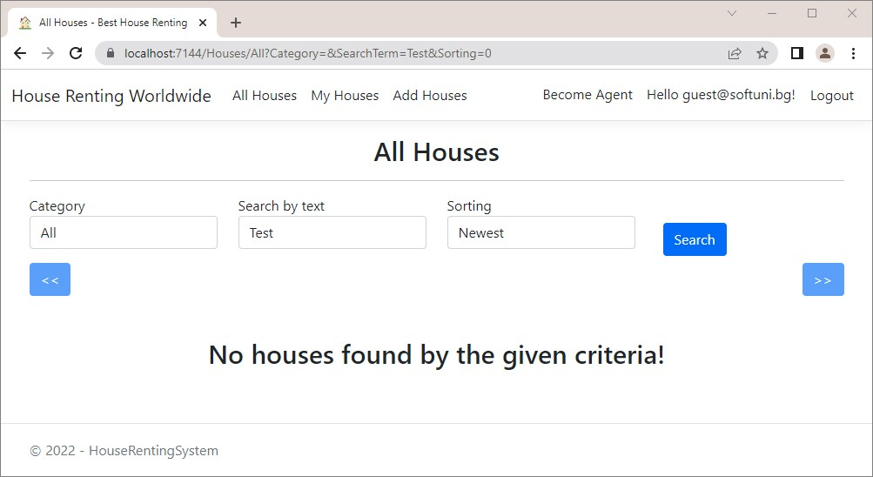

If **there are houses**, **each of them should be** **displayed** by the **"_HousePartial.cshtml"** **partial view**, which we will implement next. As the code is a lot to write, you can copy it from here:

@model AllHousesQueryModel

|  |
| --- |
| @{  ViewBag.Title = "All Houses";  }    <h2 class="text-center">@ViewBag.Title</h2>  <hr />    <**form** method="get">  <div class="row">  <div class="form-group col-md-3 d-flex justify-content-between">  <div class="form-group">  <**label** **asp-for**="Category"></**label**>  <**select** **asp-for**="Category" class="form-control">  <**option** **value**="">All</**option**>  @foreach (var category in Model.Categories)  {  <**option** **value**="@category">@category</**option**>  }  </**select**>  </div>  </div>    <div class="form-group col-md-3">  <**label** **asp-for**="SearchTerm"></**label**>  <**input** **asp-for**="SearchTerm" class="form-control" placeholder="..."> </div>    <div class="form-group col-md-3">  <div class="form-group">  <**label** **asp-for**="Sorting"></**label**>  <**select** **asp-for**="Sorting" class="form-control">  <**option** **value**="0">Newest</**option**>  <**option** **value**="1">Lowest price first</**option**>  <**option** **value**="2">Not rented first</**option**>  </**select**>  </div>  </div>    <div class="col-md-3">  <div class="form-group mt-4 p-2">  <input type="submit" value="Search" class="btn btn-primary" />  </div>  </div>  </div>  </**form**>    @{  var previousPage = Model.CurrentPage - 1; if (previousPage < 1)  {  previousPage = 1;  }  var maxPage = Math.Ceiling((double)Model.TotalHousesCount /  AllHousesQueryModel.HousesPerPage); |
| }    <div class="row mb-5">  <div class="col-md-6 d-grid gap-2 d-md-flex justify-content-md-start">  <**a** class="btn btn-primary @(Model.CurrentPage == 1 ? "disabled" : string.Empty)"  **asp-controller**="House" **asp-action**="All"  **asp-route-currentPage**="@previousPage" **asp-route-category**="@Model.Category" **asp-route-searchTerm**="@Model.SearchTerm"  **asp-route-sorting**="@((int)Model.Sorting)"><<</**a**> </div>  @{  var shouldButtonBeDisabled = Model.CurrentPage == maxPage ||  !Model.Houses.Any();  }  <div class="col-md-6 d-grid gap-2 d-md-flex justify-content-md-end">  <**a** class="btn btn-primary  @(shouldButtonBeDisabled ? "disabled" : string.Empty)" **asp-controller**="House" **asp-action**="All"  **asp-route-currentPage**="@(Model.CurrentPage + 1)"  **asp-route-category**="@Model.Category" **asp-route-searchTerm**="@Model.SearchTerm"  **asp-route-sorting**="@((int)Model.Sorting)">>></**a**>  </div>  </div>    @if (!Model.Houses.Any())  {  <h2 class="text-center">No houses found by the given criteria!</h2> }    <div class="row">  @foreach (var house in Model.Houses) {  <**partial** **name**="_HousePartial" **model**="@house" /> }  </div> |

Create the **"_HousePartial.cshtml"** **partial view** in the "**/Views/Houses**" **folder**. It should **accept** a **HouseViewModel** and **display the house card**. If the **house is rented**, display a **[Leave]** **button**. If not, show a **[Rent]** **button**. If the **current user is not authenticated** (as the "**All Houses**" page is accessible to anyone), do not show **any buttons**, except for the **[Details]** one.

Copy the code from here:

@model HouseServiceModel

<div class="col-md-4">

<div class="card mb-3">

<img class="card-img-top" src="@Model.ImageUrl" alt="House Image">

<div class="card-body text-center">

<h4>@Model.Title</h4>

|  |
| --- |
| <h6>Address: <b>@Model.Address</b></h6>  <h6>  Price Per Month:  <b>@String.Format("{0:f2}", Model.PricePerMonth) BGN</b> </h6>  <h6>(@(Model.IsRented ? "Rented" : "Not Rented"))</h6>  <br />  <a asp-controller="House" asp-action="Details" asp-route-id="@Model.Id" class="btn btn-success">Details</a> @if (this.User.Identity.IsAuthenticated)  {  <a asp-controller="House" asp-action="Edit" asp-route-id="@Model.Id" class="btn btn-warning">Edit</a>  <a asp-controller="House" asp-action="Delete" asp-routeid="@Model.Id"  class="btn btn-danger">Delete</a>  <p></p>  @if (!Model.IsRented)  {  <form class="input-group-sm" asp-controller="House" asp-action="Rent" asp-route-id="@Model.Id" method="post">  <input class="btn btn-primary" type="submit" value="Rent" />  </form>  } else  {  <form asp-controller="House" asp-action="Leave" asp-route-id="@Model.Id" method="post">  <input class="btn btn-primary" type="submit" value="Leave"  />  </form>  }  }  </div>  </div>  </div> |

Try out if the **controller method is working correctly with the services** in the browser. To do this, comment out the **HouseController** **class code**, which **gives errors** and **run the app**.

The "**All** **Houses**" page should look like before and **work as expected**. Try out the **searching**, **paging** and **sorting** **functionalities**.

Note that when you **add searching and sorting criteria** on the page, they will **be added as part of the URL** – that's what the **tag helpers** we added to the **view** do:

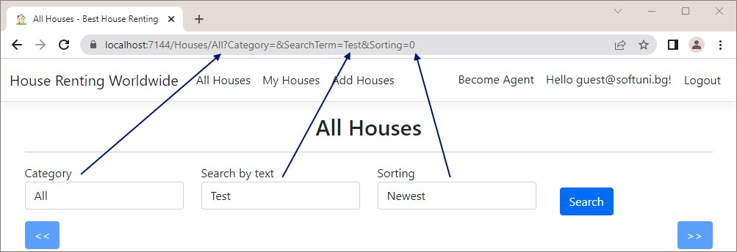

# Implement "My Houses" page

Now it's time to implement the "**My Houses**" page. It will have **different implementations** for **users** and for **agents**. When the **user is not an agent**, they will **see the houses they rented**. When the **user is an agent**, they will see the **houses they created**. The page should look like this:

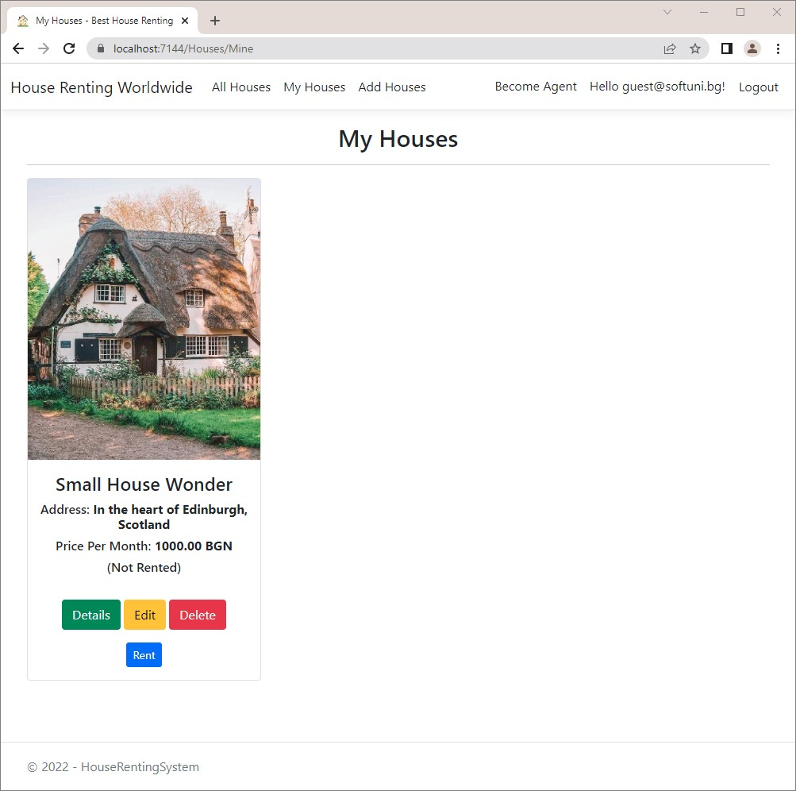

Modify the **Mine(…)** **method** in the **HouseController** **class** to **satisfy the above requirements** and to use **service** **methods**.

This method needs **service methods for getting the houses by a given agent id** (when the **user is an agent**) and **by a** **user** **id** (when the **user is not an agent**).

**Define these two methods** in the **IHouseService**:

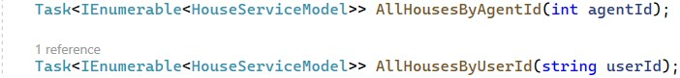

Now let's write **these methods** in the **HouseService**. We will add a **separate method for projecting a filtered House collection** to **List<HouseServiceModel>**. Note that we should **return a collection of type HouseServiceModel**, as the **AllHousesQueryModel** requires it.

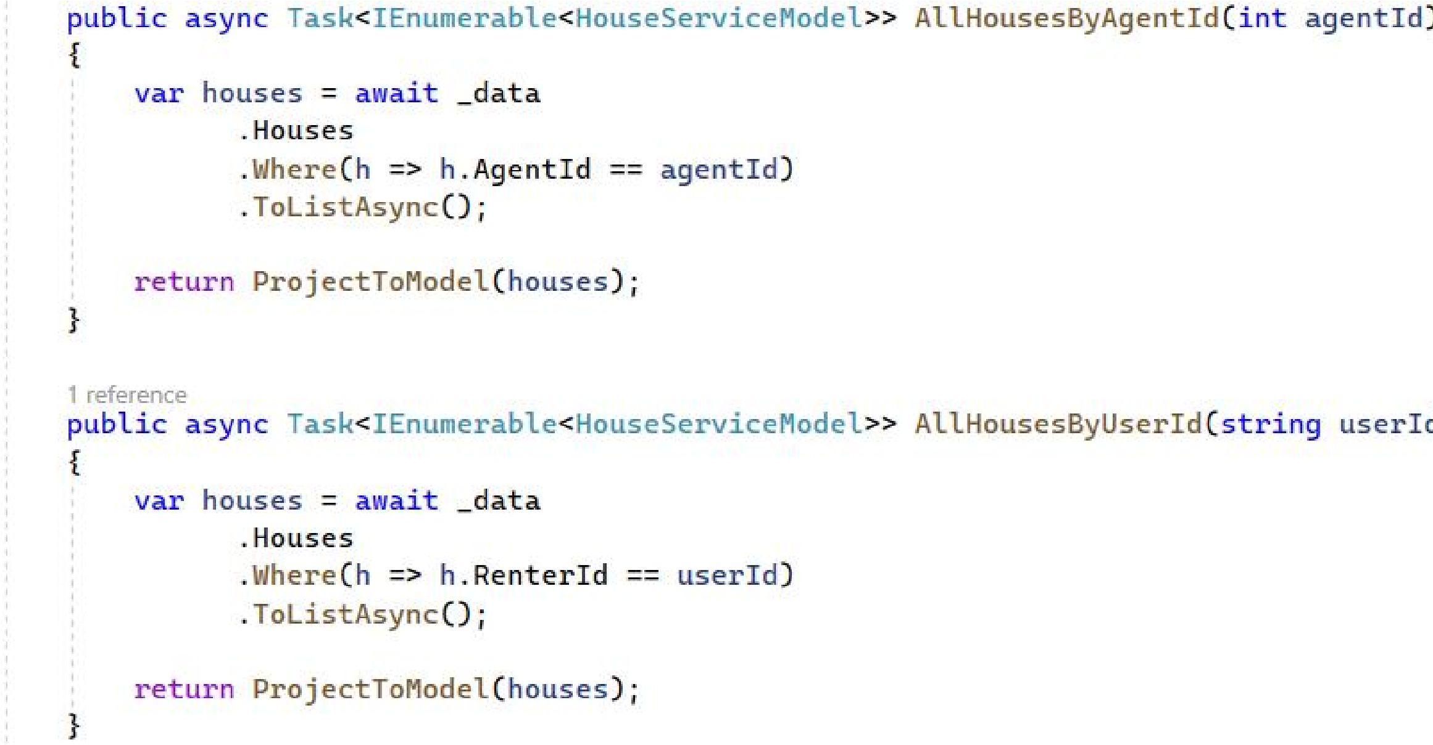Write the following **methods** in the **HouseService** **class** like this:

As you can see, we are going to need an additional method in the **HouseService** class, that should look like this:

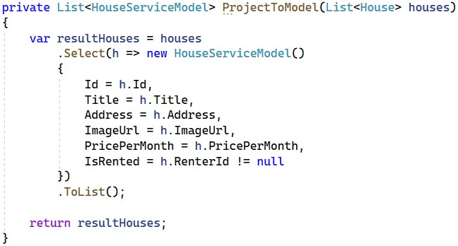

**Modify** the **Mine()** **method** to **use the service methods** to **get the filtered houses collection** and **pass it to a view**:

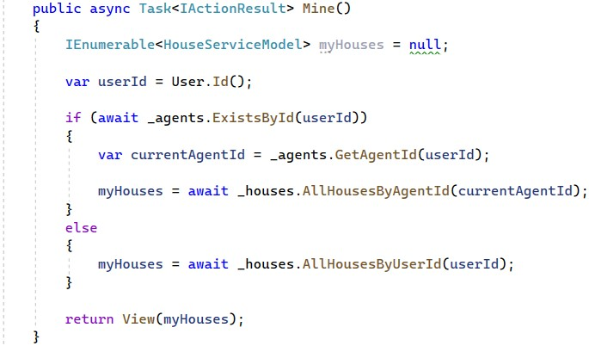

Finally, write the **"Mine.cshtml"** **view**, which should only **accept a model** and **use** the **"_HousePartial.cshtml"** **partial view** to **display each house**.

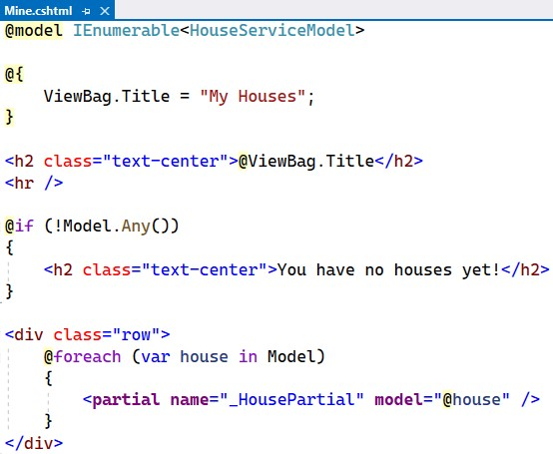

Test the "**My** **Houses**" **page functionality** in the browser. When you **create a house as an agent** you should see your **created houses**. When you **rent a house as a non-agent user**, you should see your **rented houses**.

# Implement "Details" page

The "**Details**" **page** should **show the house details** of a **house by a given id**. It looks like this:

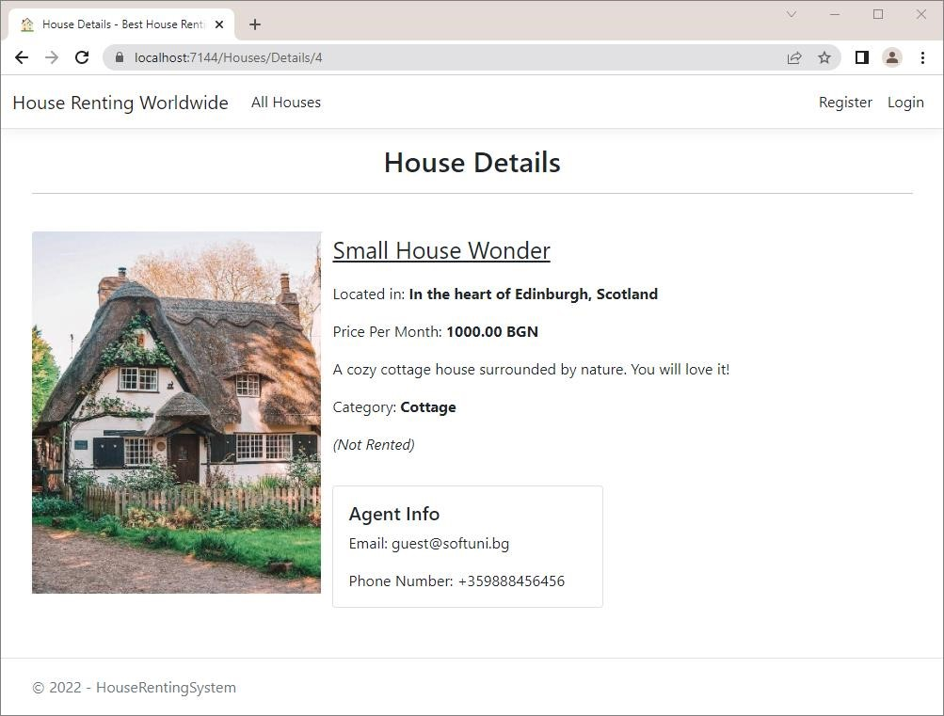

The next method we should **modify** is **Details(int** **id)** in the **HouseController**. It will have logic for **checking** **whether a house with a given id exists** and for **projecting the House** to a **HouseDetailsViewModel**.

As we will implement this logic in a **service**, we need **service models**. Create the **HouseDetailsServiceModel** in "**/Services/Houses/Models**". It should **inherit** **HouseServiceModel** and have the **properties** of the **HouseDetailsViewModel** **class**:

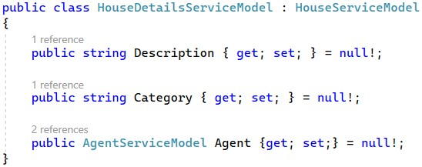

Now let's write the logic of **service methods**. Create the following **service methods** in the **IHouseService** **interface** and the **HouseService** **class**. **Get the house from the database** and **project it to** **a** **HouseDetailsViewModel**.

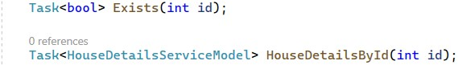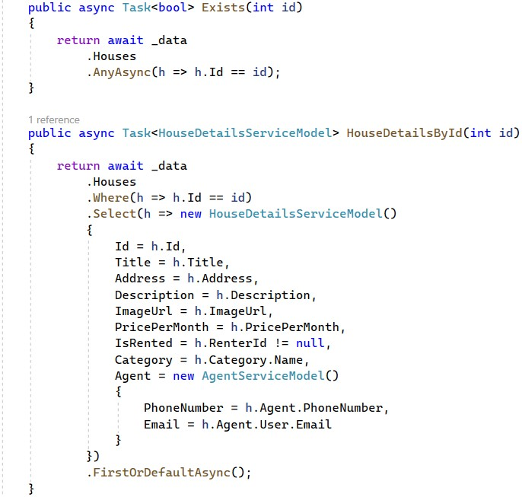

**Modify** the **Details(int** **id)** **method** in the **HouseController** to use the **service methods**:

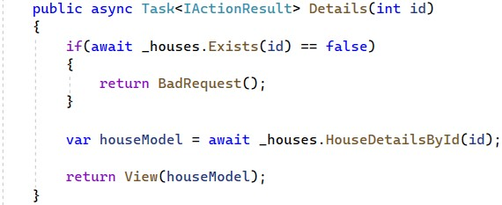

Implement the **"Details.cshtml"** **view**, which should **accept a model** and **use its properties to display the house** **data**. Note that the **[Edit]**, **[Delete]**, **[Rent]** and **[Leave]** **buttons** should be **displayed only to authorized** **users**, as this page is accessible to everyone. As it is a lot of code to write, you can copy it from here:

|  |
| --- |
| @model HouseDetailsServiceModel    @{  ViewBag.Title = "House Details";  }    <h2 class="text-center">@ViewBag.Title</h2>  <hr />    <div class="container" style="display:inline">  <div class="row">  <div class="col-4">  <img class="card-img-top" style="width: 20rem;" src="@Model.ImageUrl" alt="House Image">  </div>  <div class="card col-8 border-0">  <p style="font-size:25px;"><u>@Model.Title</u></p>  <p>Located in: <b>@Model.Address</b></p>  <p>  Price Per Month:  <b>@String.Format("{0:f2}", Model.PricePerMonth) BGN</b> </p>  <p>@Model.Description</p>  <p>Category: <b>@Model.Category</b></p>  <p><i>(@(Model.IsRented ? "Rented" : "Not Rented"))</i></p>  <div class="form-inline">  @if (this.User.Identity.IsAuthenticated)  {  <**a** class="btn btn-warning" **asp-controller**="House" **aspaction**="Edit"  **asp-route-id**="@Model.Id">Edit</**a**>  <**a** class="ml-2 btn btn-danger" **asp-controller**="House" **aspaction**="Delete"  **asp-route-id**="@Model.Id">Delete</**a**>  @if (!Model.IsRented)  {  <**form** class="ml-2" **asp-controller**="House" **asp-action**="Rent" **asp-route-id**="@Model.Id" method="post">  <input class="btn btn-primary" type="submit" value="Rent" />  </**form**>  } else  {  <**form** class="ml-2" **asp-controller**="House" **asp-action**="Leave" **asp-route-id**="@Model.Id" method="post"> <input class="btn btn-primary" type="submit" value="Leave" />  </**form**>  }  }  </div> |

<p></p>

<div class="card" style="width: 18rem;">

<div class="card-body">

<h5 class="card-title">Agent Info</h5>

<p class="card-text">Email: @Model.Agent.Email</p>

<p class="card-text">Phone Number: @Model.Agent.PhoneNumber</p>

</div>

</div>

</div>

</div> </div>

Try out the "**Details**" **page** in the browser and make sure that it **looks like shown above**.

# Implement "Edit House" page

Let's modify the the **Edit(int** **id)** and **Edit(int** **id,** **HouseFormModel** **model)** **methods** in the

**HouseController** for **editing an existing house**. We should check whether a **house with the given id exists** in the database and if the **current logged-in user is the agent**, who **created the house** (only the creator of a house can edit it). In both cases, the method should return **an error if something is wrong**.

First, go to the **IHouse** interface and create the following service method:



Do that for the **HouseService** class, too. The method should **find by id** the house that we want to **edit**, **change** the needed info and **save** the **changes** to the database.

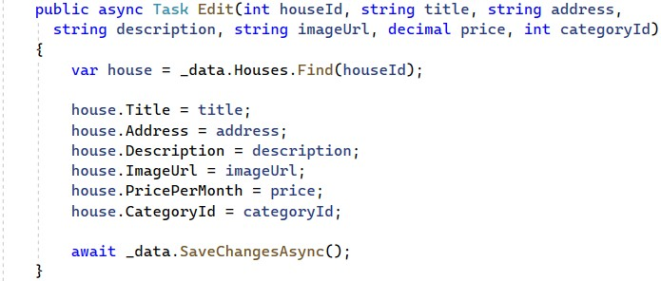

Next, we need to modify the **Edit(int id)** and … controller methods from the **HouseController**. Do it like this:

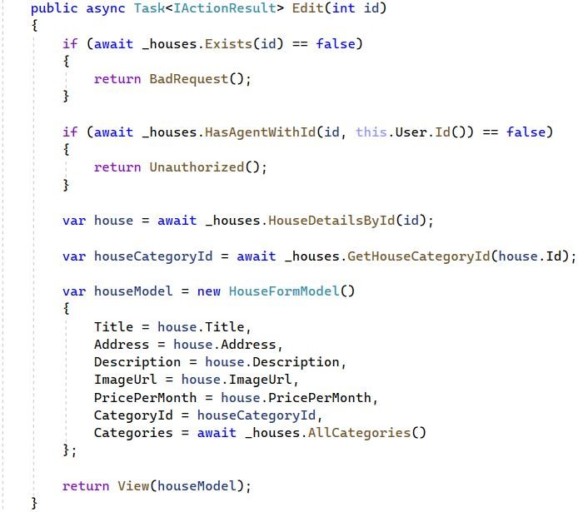

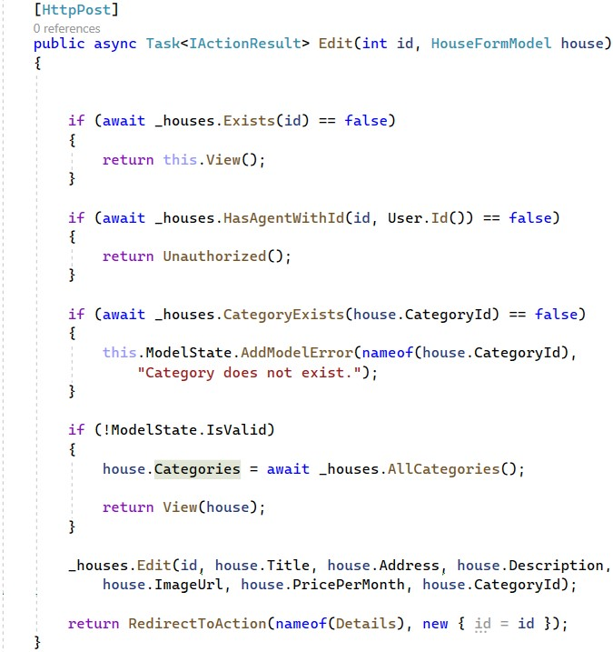

As you can see, we need some additional methods that checks if the agent that created the house, is the currently signed in agent and another one that returns the category of a house.

Write them in the **IHouseService** interface and in the **HouseService** class like shown below:

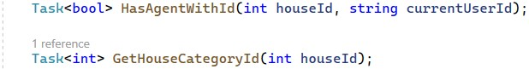

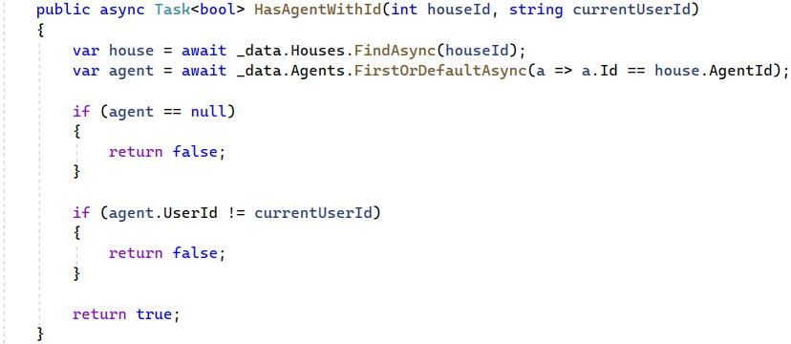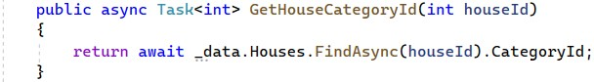

The **"Edit.cshtml"** **view** should **render** the **"_HouseFormPartial.cshtml"** **partial view** and should look like this:

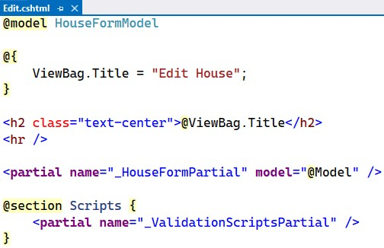

Try the "Edit" functionality in the browser. After **successful edit**, you should be **redirected** to the "**Details**" **page** and the **changes should be saved** to the **database**, as well.

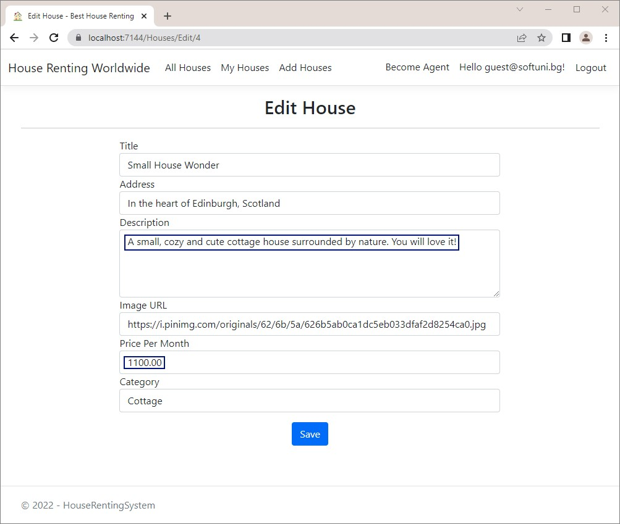

# Implement "Delete House" page

The "**Delete**" **functionality** is next to be implemented in our app. The page should look like this:

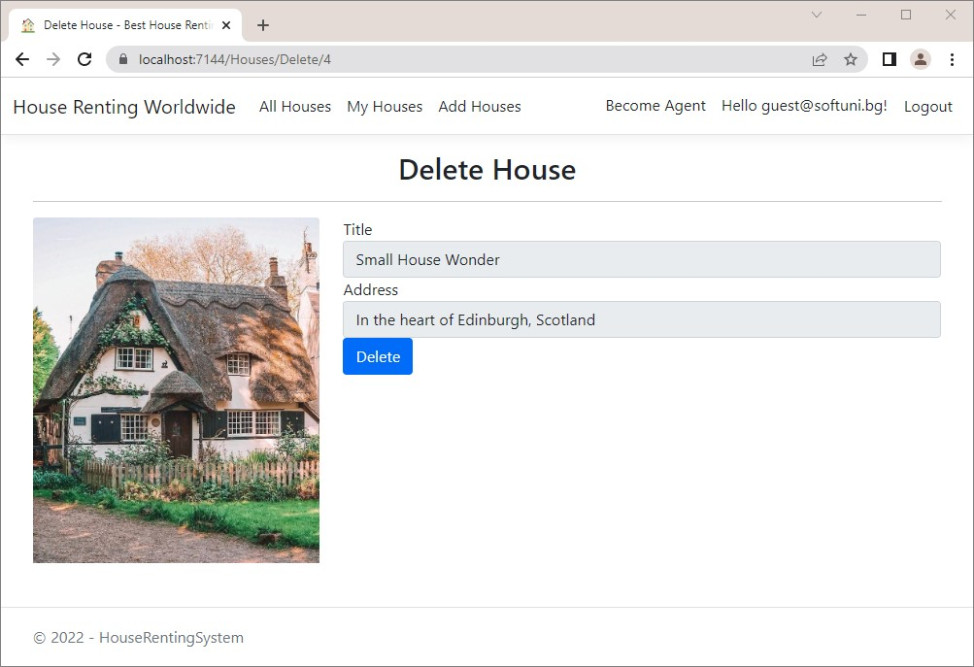

First, modify the **IHouseServices** interface and the **HouseService** class by adding the **Delete(int houseId)** service method. The method is quite simple – it **finds** **by id the house** that we want to **delete** and **removes** it from the **database**.

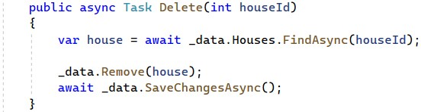

Before modifying the **Delete(int id)** and **Delete(HouseDetailsViewModel** **model)** methods in the **HouseController,** we should **add** **properties** to the **HouseDetailsViewModel** view model, that we created at the beginning of this workshop.

It should look like this:

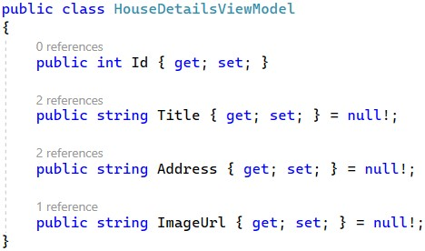

Now, our next step is to modify the **Delete(int id)** method and the **Delete(HouseDetailsViewModel** **model)** method in the **HouseController**.

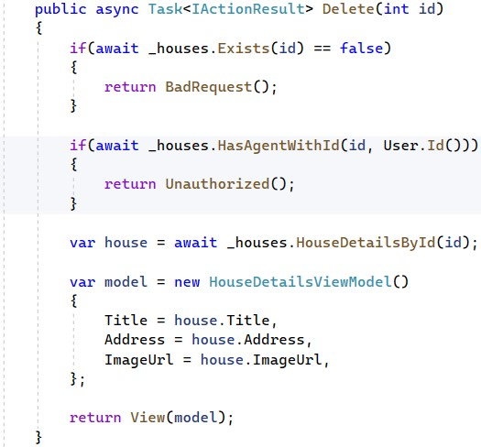

In the **HouseController** **class** write the **Delete(HouseViewModel** **model)** **method**, which should **delete a given house** if it **exists** and if the **current user is its agent**. Then, the user should be **redirected** to the "**All** **Houses**" **page**.

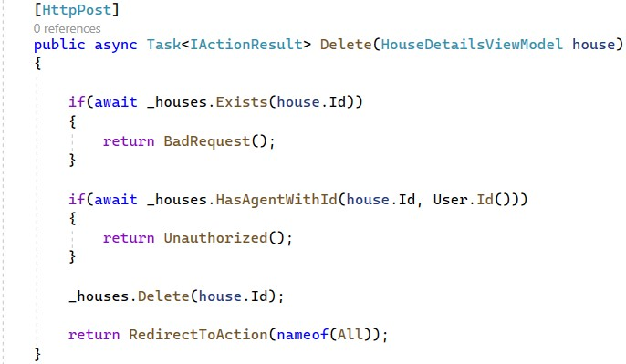

Our final step is to implement the "**Delete.cshtml**" view. Add a **form for deleting a house**. Note that the user should **not be able to edit** **the house data**, e.g. the **<input>** **tags** should be **disabled**.

You can copy the code from here:

@model HouseDetailsViewModel

@{

ViewBag.Title = "Delete House";

}

<h2 class="text-center">@ViewBag.Title</h2>

<hr />

<**form** **asp-action**="Delete">

<div class="row">

<div class="col-md-4">

<img class="card-img-top" src="@Model.ImageUrl" alt="House Image"> </div>

<div class="col-md-8">

<div class="form-group">

<**label** **asp-for**="Title" class="control-label"></**label**>

<**input** **asp-for**="Title" class="form-control" disabled="disabled" /> </div>

<div class="form-group">

<**label** **asp-for**="Address" class="control-label"></**label**>

<**input** **asp-for**="Address" class="form-control" disabled="disabled" /> </div>

<div class="form-group">

<input type="submit" value="Delete" class="btn btn-primary" />

</div>

</div>

</div> </**form**>

Test the "**Delete**" functionality in the browser and check if the changes are saved to the database.

# Implement "Rent House" functionality

The next functionality we shall implement is for **renting a house**. Modify the **Rent(int** **id)** **method** in the **HouseController** **class**, which should be invoked on a "**POST**" **request** to "**/Houses/Rent/{id}**".

Before that, add the following methods to the **IHouseService** interface and the **HouseService** class:

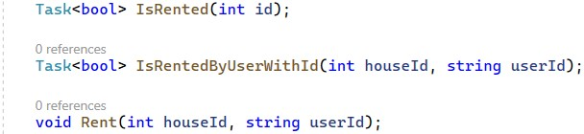

The first two methods perform checks regarding the house that we want to rent. If a user wants to **rent a house**, make sure that a **house with a given id exists** in the database and that the **house is not already rented**.

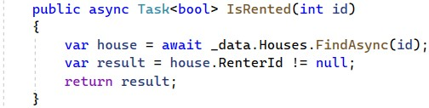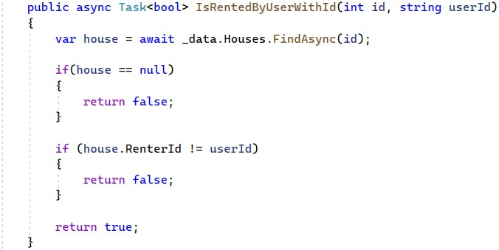

Then, **set the house RenterId** in the **database** to the **current user id** and **save it**.

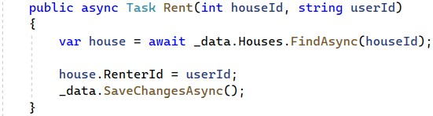

After that, it's time to modify the **Rent(int id)** method in the **HouseController**. Do it like this:

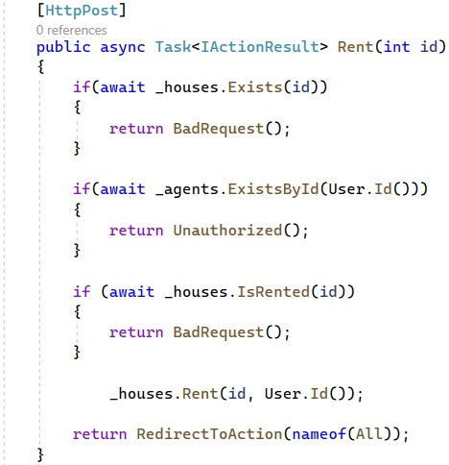

Now try out the "**rent**" **functionality**. To do this, **log in as a** **user**, who is **not an agent**, and go to "**/Houses/Rent/{id}**" with the **house id** in the **URL**.The **id** should be of a **house**, which is **not already rented.** If the **rent is successful**, you should be **redirected** to the "**My** **Houses**" **page** and the **rented** **House** should have a **RenterId** the **database**:

# Implement "Leave House" functionality

The last functionality we are going to implement today is the "**leave** **house**" **functionality**. It should also be **invoked** on a "**POST**" **request** to "**/Houses/Leave/{id}**".

First, implement service methods to the **IHouseService** interface and the **HouseService** class. They should look like this:

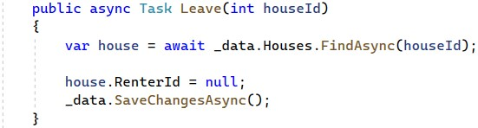

Modify the **Leave(int** **id)** **method** of the **HouseController** **class**. Note that for a house to be **left** it should **exist** and **be rented and the current user** should be **the one who rented the house**. If these requirements are satisfied, set the **RenterId** of the **House** **record** to **NULL** the **database** and **redirect** to the "**My** **Houses**" **page**.

The **controller action** should look like this:

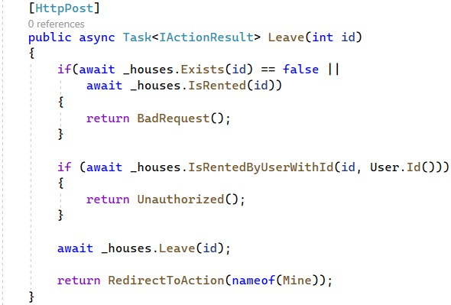

Try to **leave the house** you rented on the previous task by going to "**/Houses/Leave/{id}**" with the **house** **id**. If it is successful, you should be again **redirected** to the "**My** **Houses**" **page** and the **House** **record** should have a **NULL** value on **RenterId.** Don't forget to test the **model errors** on the "**Become** **Agent**" **page** – a **user with rented houses** should **not be able** **to become an agent**.